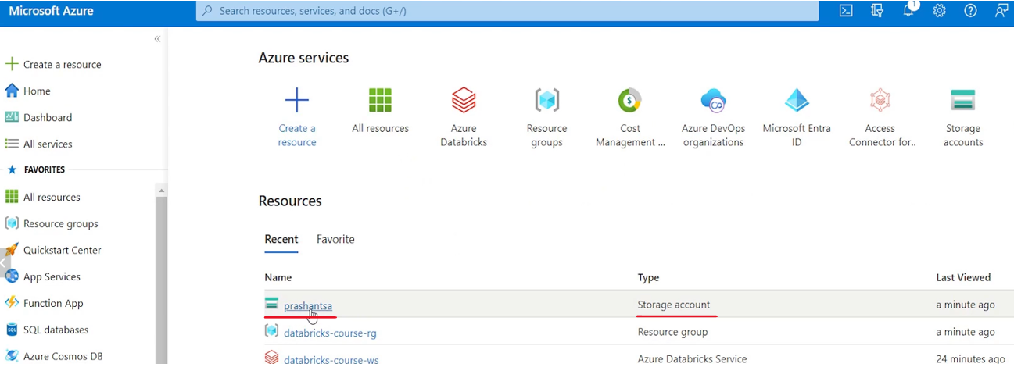

You have a lot of menus here specifically for storage account or for working with the storage account.

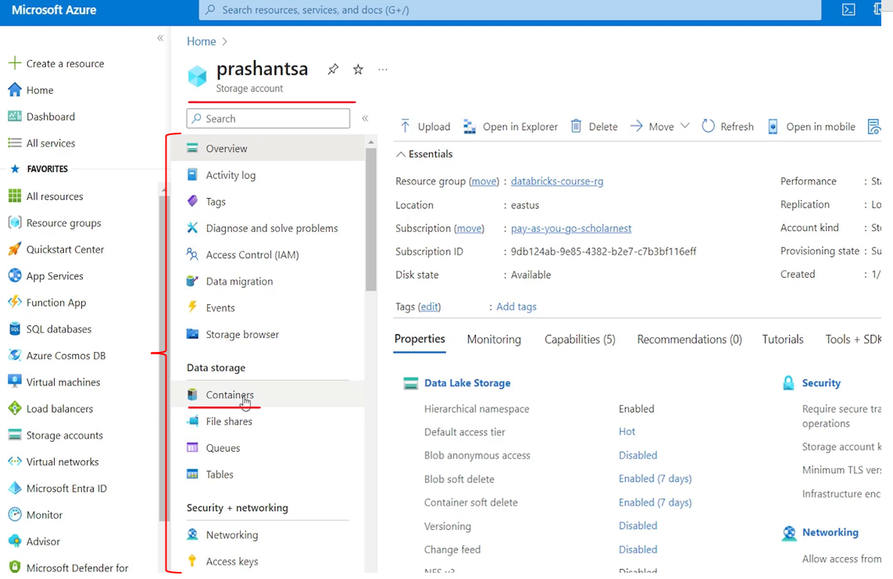

So we will go to containers and. We will try to create a new container here.

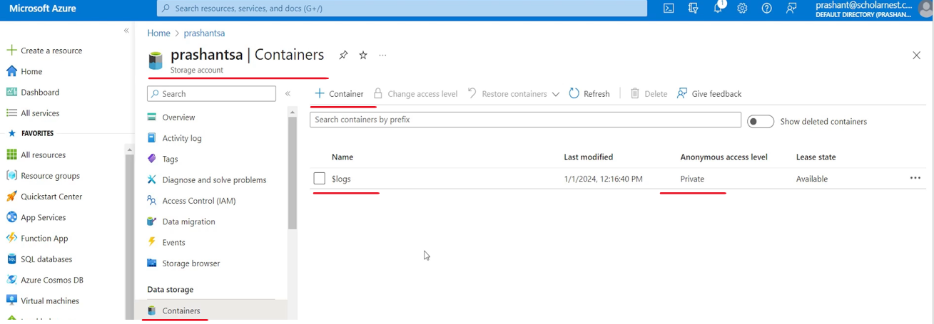

So inside the storage account we must create at least one container. Container is like a root directory inside your storage account. Storage account is just an storage account which defines some configurations like what is the, pricing tier or performance tier? What is the redundancy level? Which resource group it should be created. So account is at the top level. It's just an account. Inside the account container is your directory your root directory or your directory. You can create as many containers as you want inside your storage account. you might already see a logs container. $logs container by default, it's for Azure, it will use it for its own purpose. We will not go in there. We will create a new container. So hit the plus create container button.

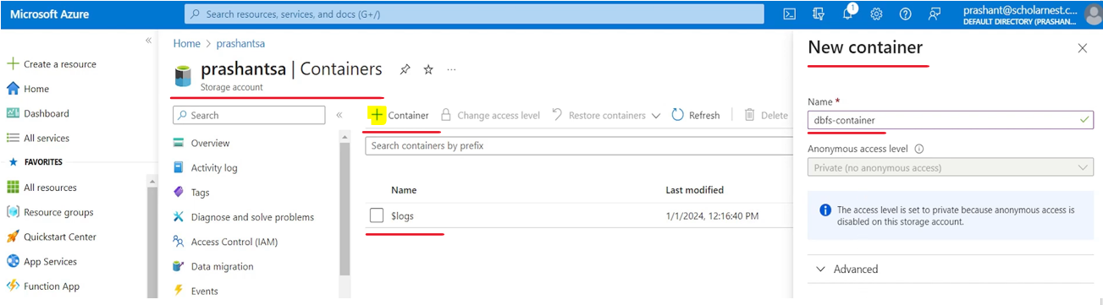

Give a name to your container. Let me see what name we have thought. Let's call it Dbfs container. Right? Because that's the purpose. That's what I want to create it for. So create Dbfs container, give a name to your container and hit the create button. Simple. And within a couple of seconds Azure will create a container for you.

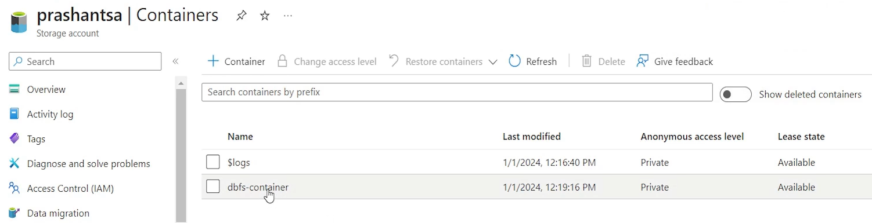

So this is my container right inside the container. From the azure itself, I can create subdirectories. Container itself is a kind of directory, but inside the container I can also create subdirectories. I can upload data files. All that we can do from the Azure cloud UI itself. But let's go with the list. So create a storage container in your storage account. That was the second step. Go to Azure Storage Account page, select containers and click Plus Create container button. Give a name to your container and hit the create button.

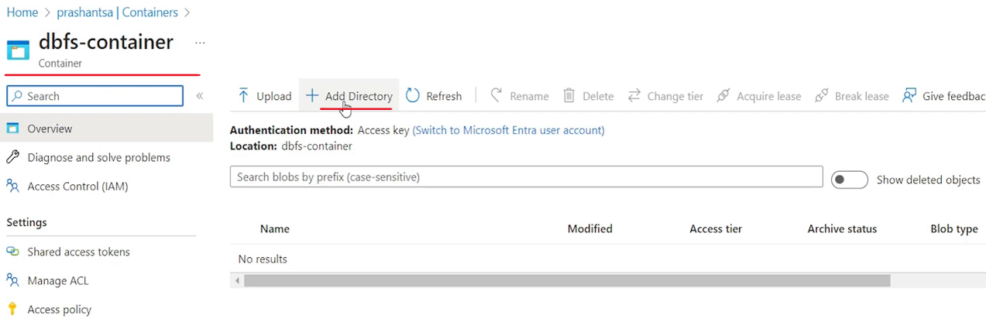

That's all. we created a container inside our storage account that's done.

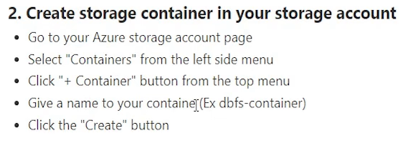

The step three is we will have to create a service principal or service user. set a password or secret for that user. And that user will have access to the storage container. And then we will use that credential, that username and password or service principal name and secret from the Databricks workspace from Dbfs to access the storage container. That's the idea.

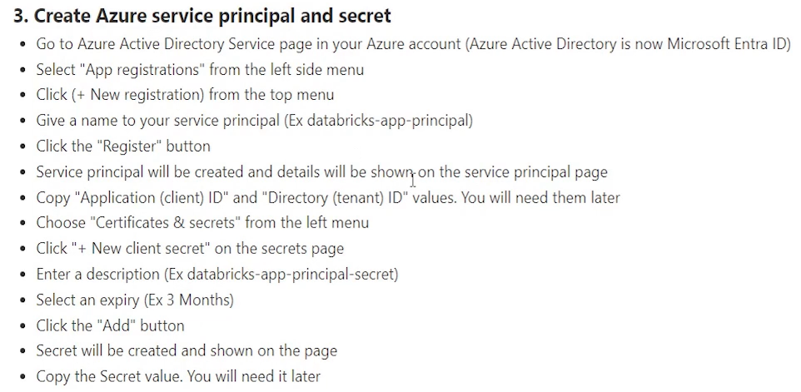

So let's create a service principal and secret. And go to your Azure Active Directory service page. Because all the user service principles, everything are created in the Azure Active Directory. So let's come here. look for your menu. you will see Microsoft entra ID. Microsoft Azure Active Directory is now renamed and rebranded as Microsoft Entra ID. Azure Active Directory is now. Microsoft Entra ID. So we come here. So go to your Azure Active Directory page in your Azure account. It is now known as Microsoft Entra ID select app registrations. We don't want to create a simple user account.

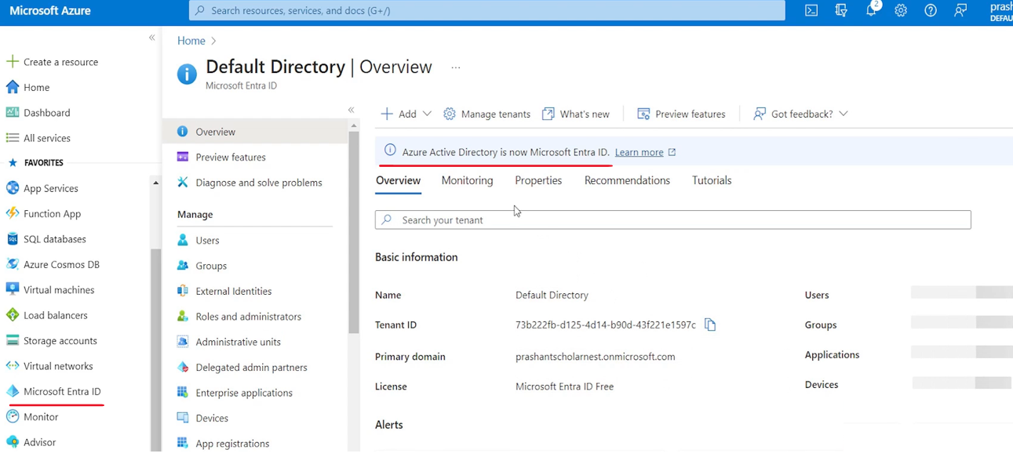

We want to create a service account right. We want to create a application user. So come to app registrations. From the left side menu you will see like this. App registrations. And then you can come to. New registration. Give a name for your app. So let's see what name we want to give. For this example, let's call it databricks-app-principal. So we call it databricks-app-principal and then hit the register button. So hit the register button.

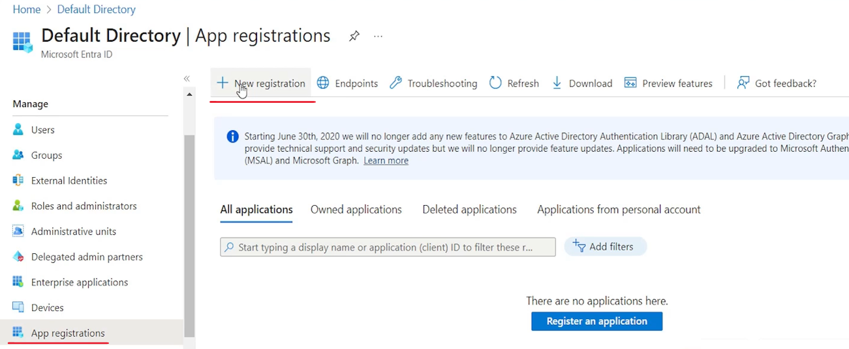

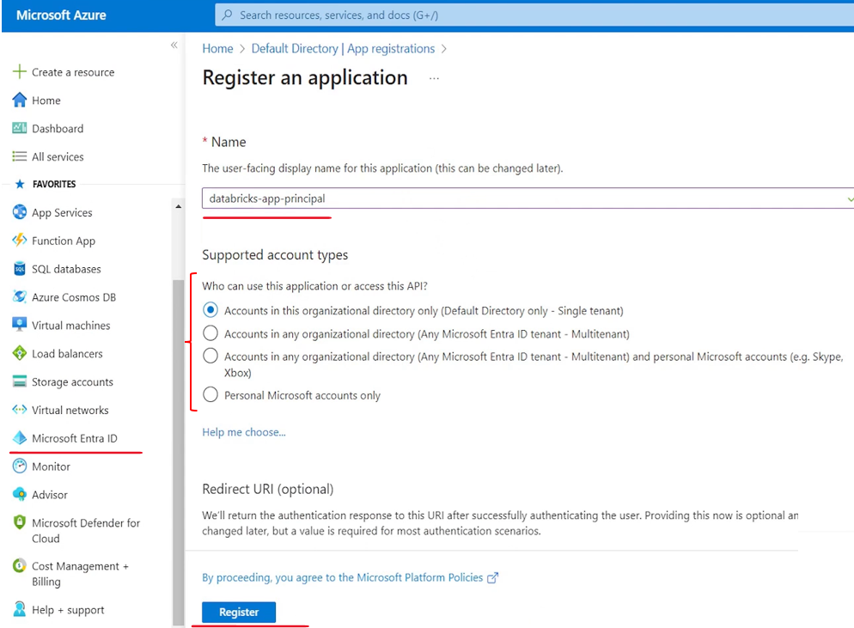

And in a couple of seconds your app registration will be done. So basically we created the app registration.

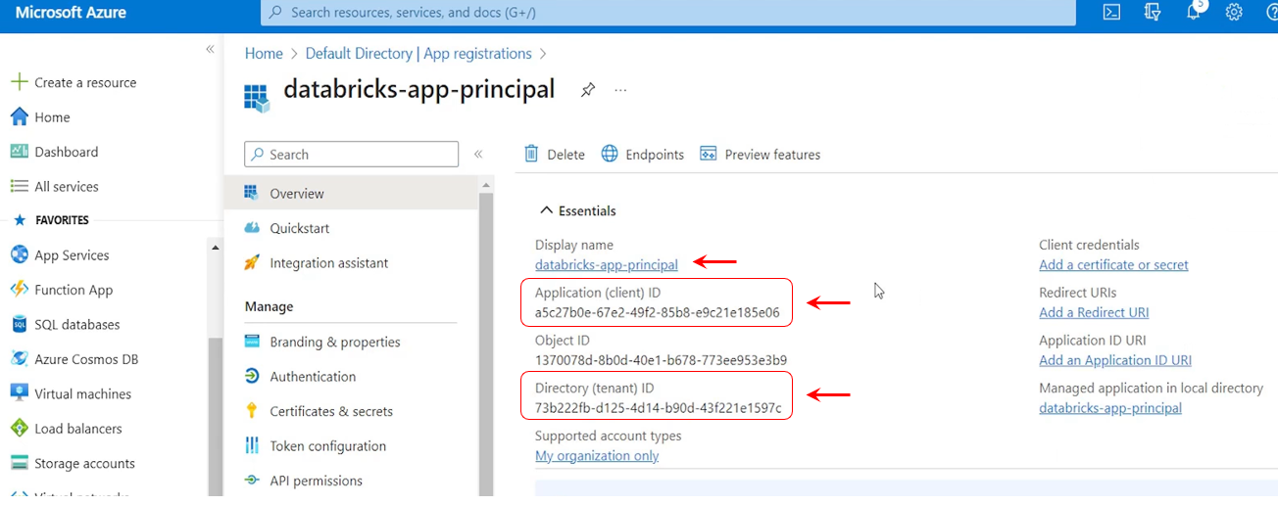

And then once your app registration is done or your service principal is created, you might want to note down these things, right. your client ID you will need it later. So just copy it somewhere and keep it safe. And then you also need this directory or tenant ID. So copy this thing and keep it safe with you. So after clicking the register button Service principle will be created. Copy the client ID and tenant ID. You will need them later and your service principle creation is done. The next step is to create certificates or secrets. So create a secret for this service principle so you can come to certificates and secrets here and create a new client secret and give some description here. Here it is databricks-app-principal-secret, you can choose the validity.

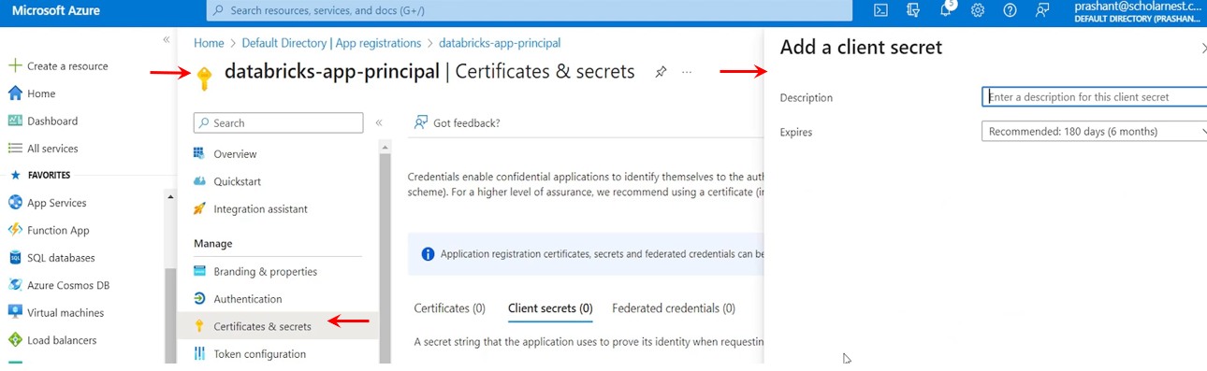

I'll go with the three months validity and add it. And that's all your secret is created.

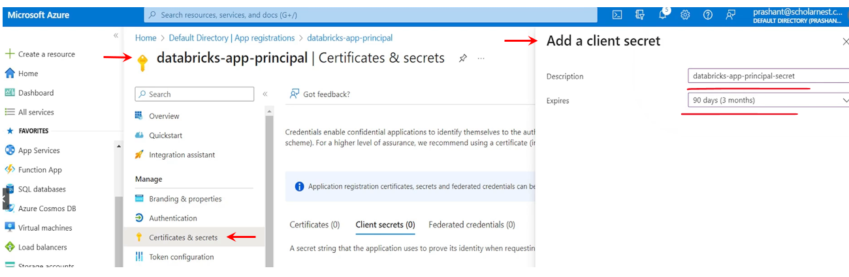

Here is the secret value. So that's like a password. Copy it and keep it in. save somewhere because you cannot see it later. It's shown only one time. So that's all. let's look at the list secret will be created and shown on the page. Copy the secret value.

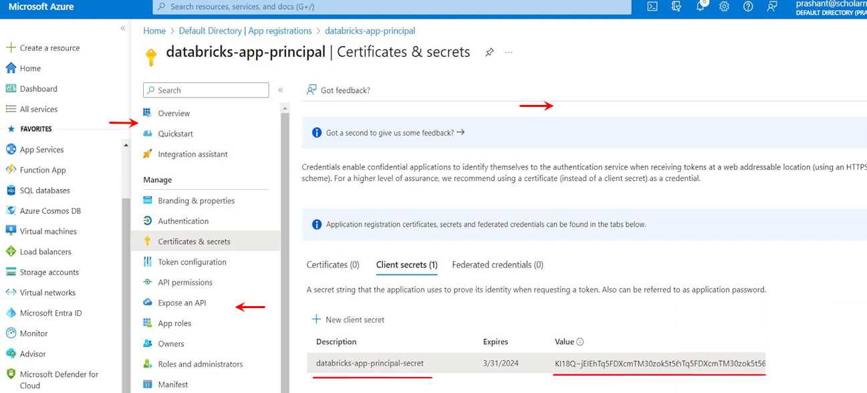

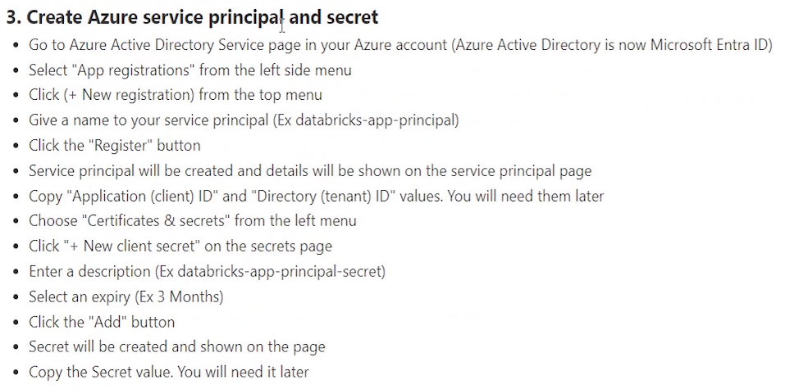

You will need it later. That's all. So we are done with the. Step three. We created Azure Service Principle and also created a secret. Next step is to grant access to the service principle for storage account.

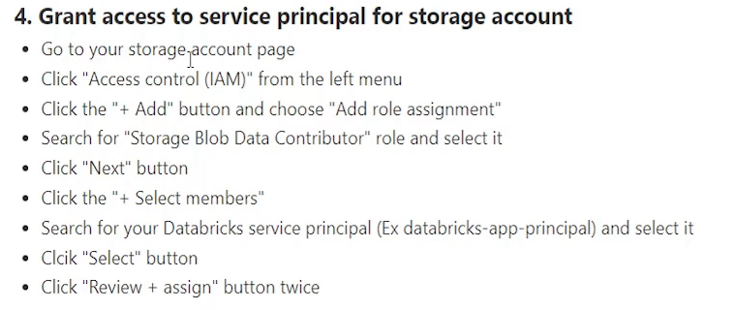

So whatever user or credential we created, that guy or that service principle should have access to the storage account. So go to the storage account page. We created a storage account earlier. Right. So you come to your storage account. And on this storage account we want to grant access for the service principle. So how to do that. Maybe you can come to Access control and IAM click the Add and click the Add Role assignment.

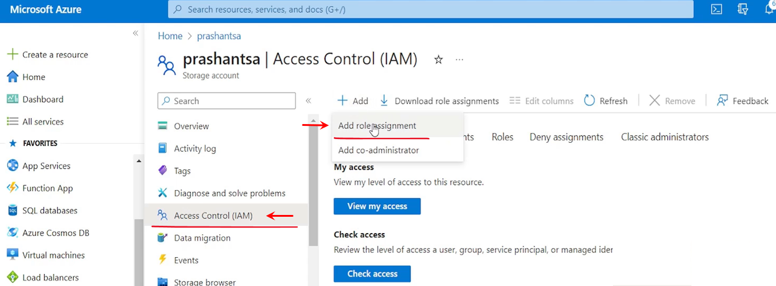

We can choose some predefined roles from here. So for that purpose Azure comes with a predefined role which is good for us. storage blob data contributor.

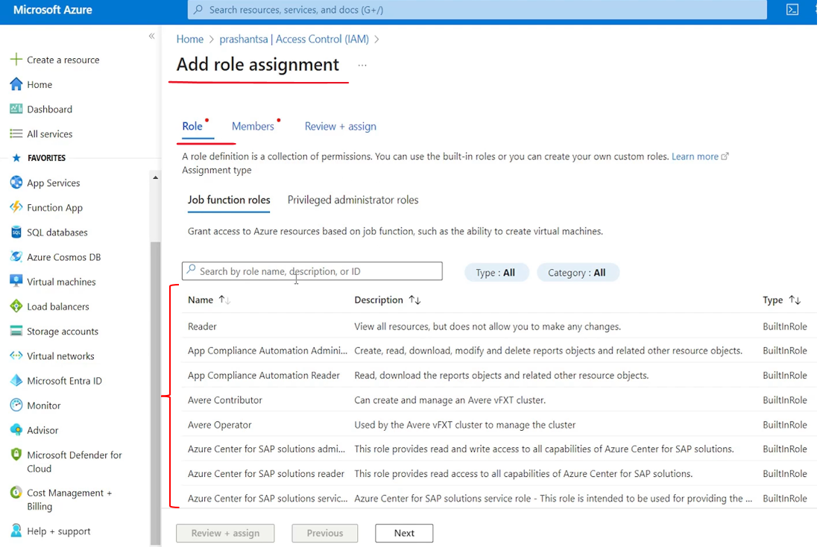

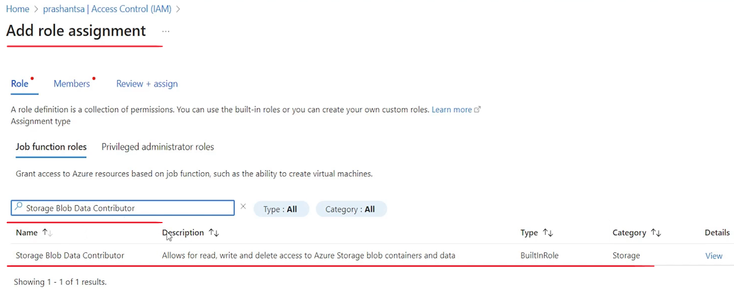

So this service principle will become a contributor for that storage account. And it can create directories create files, read, write delete. All permissions will be given. So search for the contributor role. It will show up here. Select it and click the next button. And let's see what is there. Next click the next button. Then choose plus Select Members. So we come and choose the plus Select members. And it is showing some of the user accounts I have in my Azure Active Directory. But we don't want to grant this role to those users. We want to grant this role to our Databricks app principal that we created.

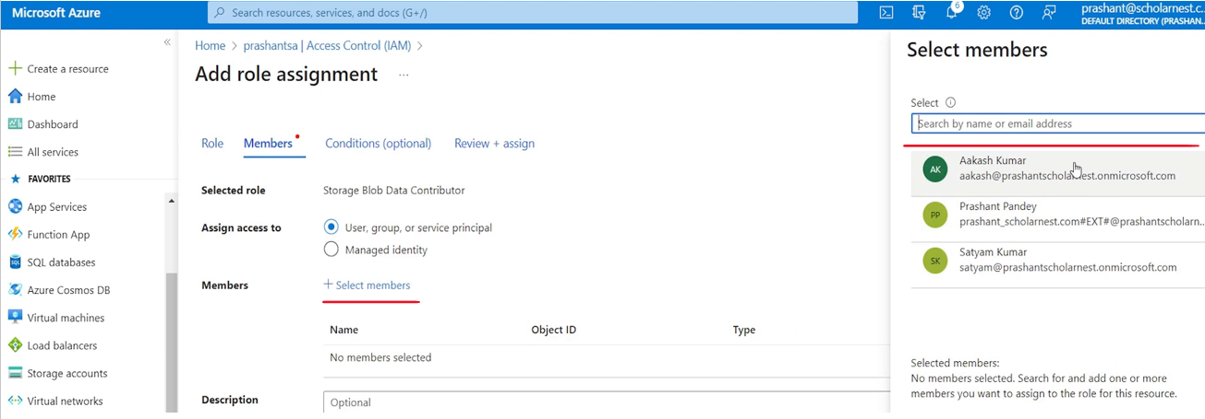

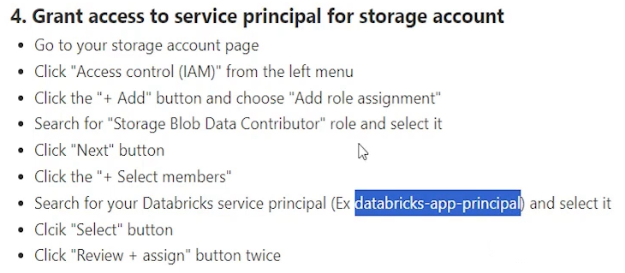

So search for the name and you will see it Databricks app Principal. That is what we created in the earlier step.

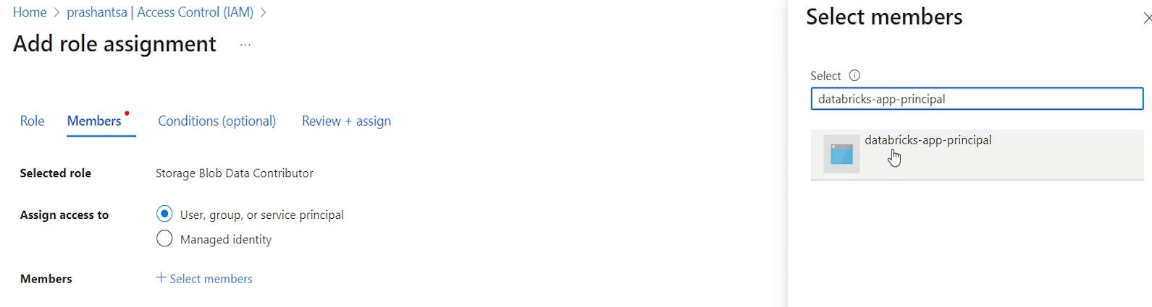

Choose this and then select, you will see it is added here. And then just hit the review and assign once again. And then that role is added. So review and assign twice and we are done.

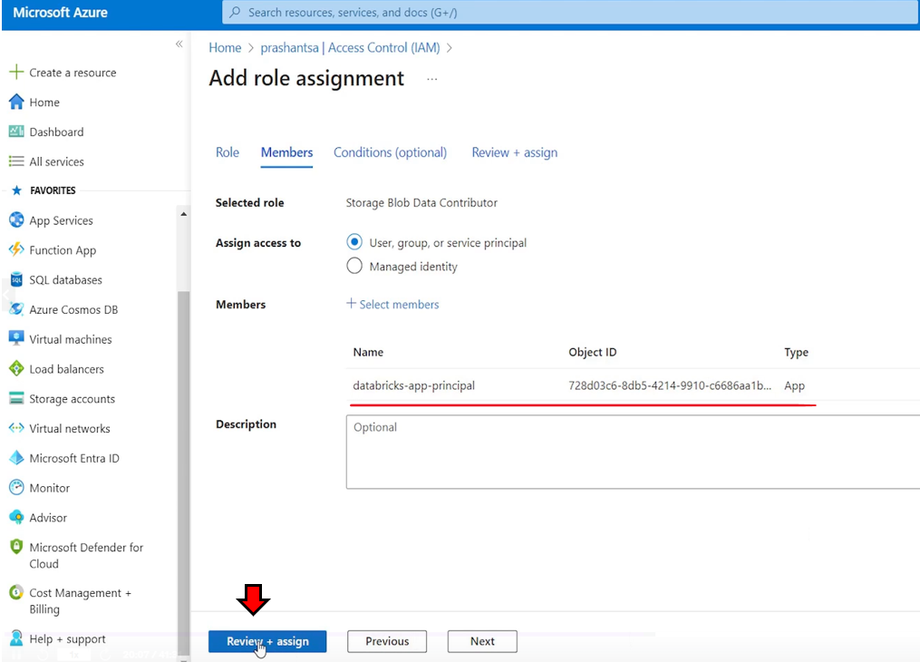

So we are done with all the four steps of preparing our storage account and container and a user ID and its secret in the Azure platform. So we are all done here.

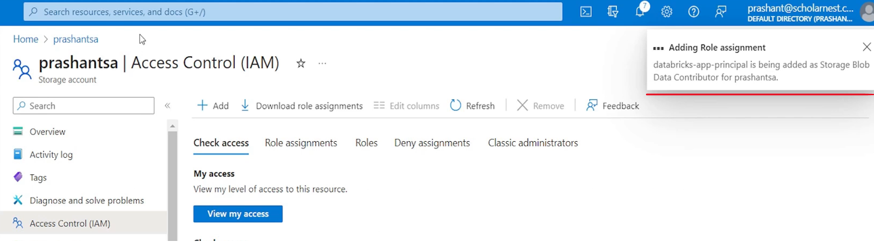

Now all we need to do is to mount that directory in the Databricks. So for mounting it in the Databricks we will have to use an API. So let's go to the API documentation for that. it's not possible to memorize all this. So what we do we look at the documentation for the API, how to mount it.

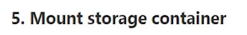

So you can come here. I have included the link here in the notebook itself. Mount ADLS Gen2 or blob storage with. adls. So come here.

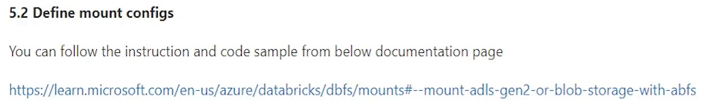

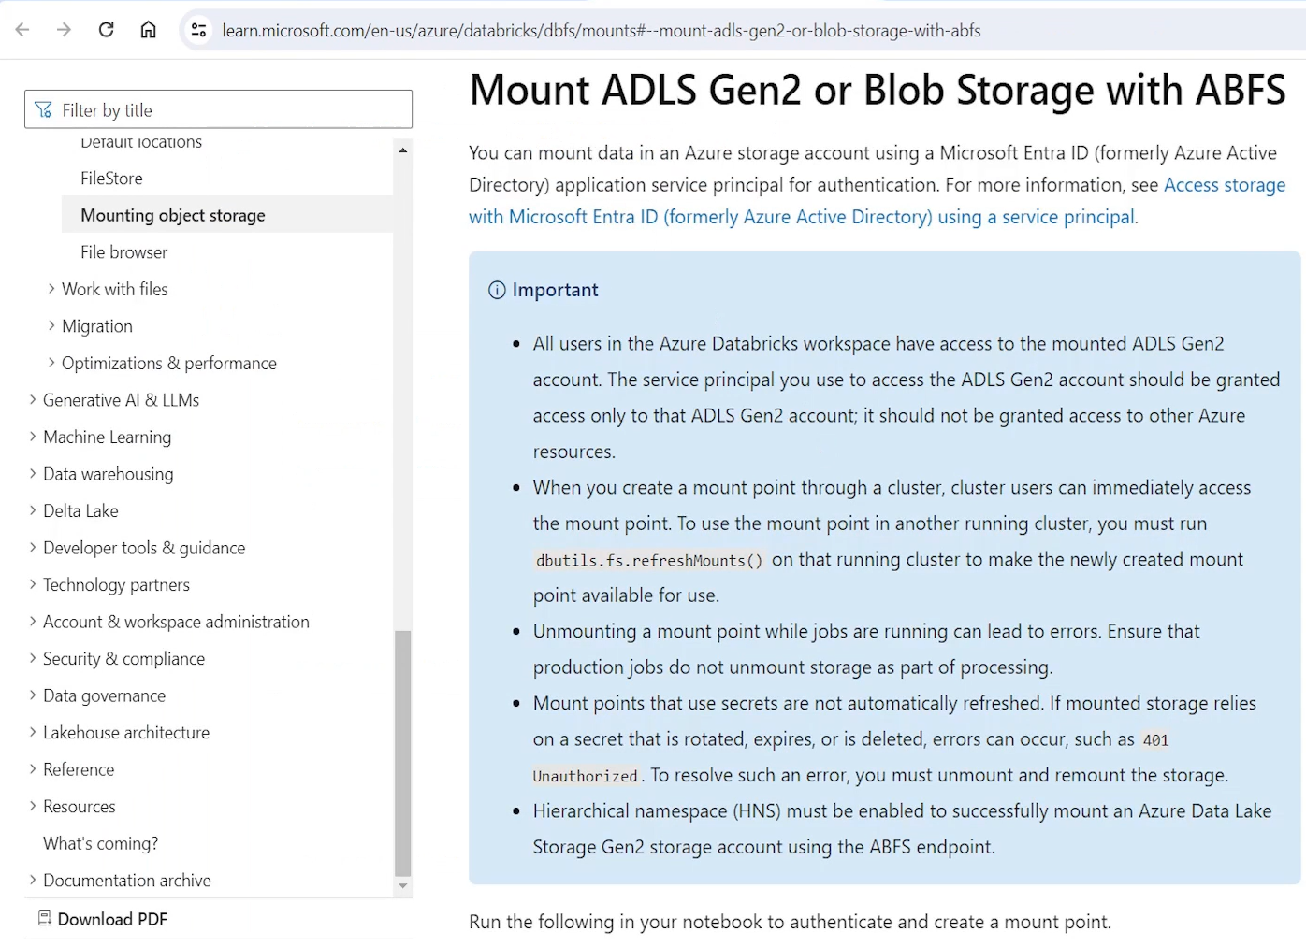

And this is the Python code. Here is a Scala code sample. You can use it. So let's copy this code from here. the top part right,

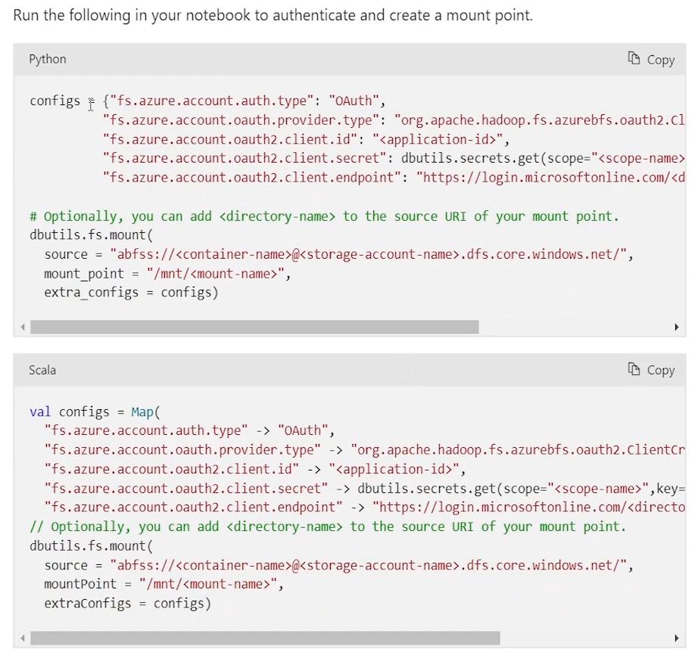

That's how we mount. So basically what we are doing, we are defining some configs. I'll cover that. And once those configs are defined we are using Databricks. Utils. Here. In the next step, a Databricks utils dot file system dot mount to mount the. A storage in the Databricks File System or Dbfs. So and for mounting this this is the Databricks command, right. It's a Databricks file system. utils package. That allows us to mount a storage directory into the dbfs. And for this we need to provide the configs and those configs we are defining here.

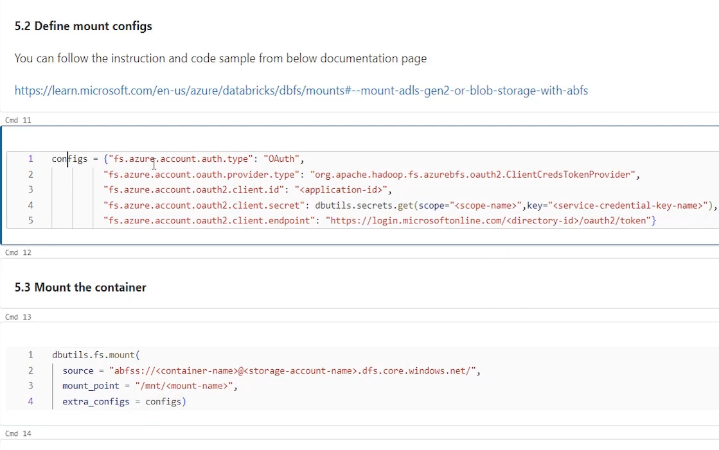

So basically what are the configs that are required. What is the protocol. Right. FS Azure auth account type. So what is the protocol we are going to use. So we will be using OAuth. And for OAuth who is the provider or what is the provider type. So provider is Microsoft itself. this is the package name for the provider. It's fixed. We will be using this. And for Authentication what is the client ID, what is the secret and what is the endpoint. So these three things we will be defining here.

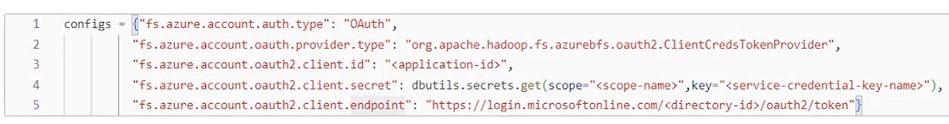

So let me create variables for these three things. So what we want to do we want to create some variables so that we can use it. The first variable is the storage account name. Let's define the storage account name. What is the storage account name? I'll come to my Azure and this is the storage account that we created. Right. So let's copy the storage account name. And we define the storage account name here. next thing is you will need the container name also. So let's create a variable for container name. And what is the container name. Inside my storage account you can come to storage account containers and copy the container name from here. This is the container which we want to mount. So let's give a container name here. And then you will need maybe one more variable mount point. So what is the name we want to give after mounting it. So let's call it files. Or you can call data or whatever. And then we will need client ID. So we will need client ID for. And you you already copied the client ID earlier. Right. We created a service account earlier. like you can come to Active Directory. look for your, App registrations and all applications. This is the app registration we created. Right. So this client ID we need this client ID I already copied it somewhere. so this is the client ID right. And in we will also need tenant ID. Tenant ID is the ID for your Active Directory. So we copied the tenant ID also earlier. So I'll paste the tenant ID and then we will also need client secret. So let me paste the secret here. And secret is visible only once. but I copied it earlier. So let me paste the secret here. Right. So this is all we need. And then once you have all this information you can create the configs in the configs, we want application ID here which is my client ID, right. So I'll use the client ID variable here.

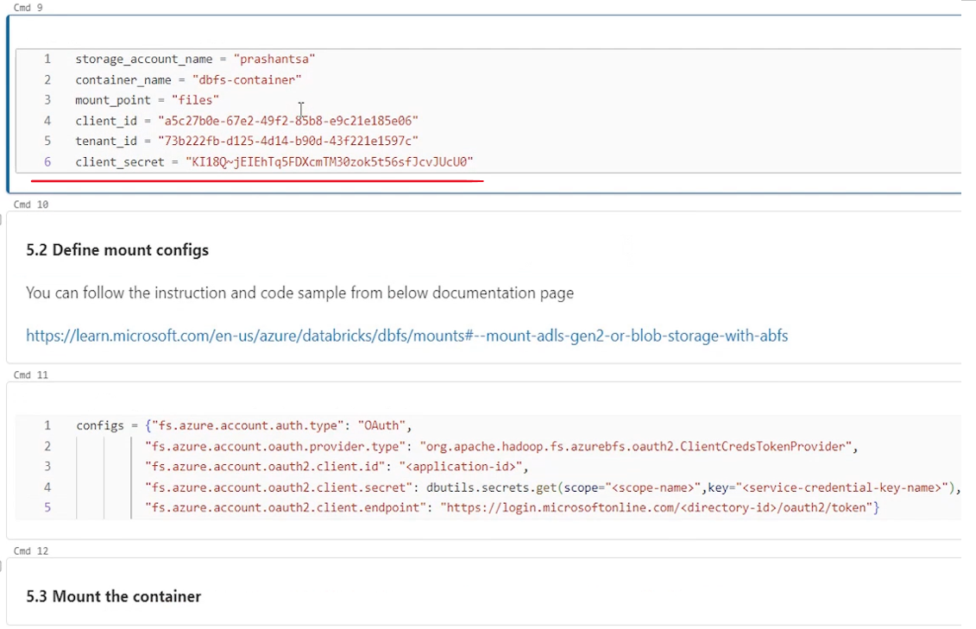

We want to use Python variable substitution for this, right. So let's make it. A variable, right? So in the config for client id we will take the client id from the variable that we defined a for secret we will be using. we will not use all this. So what we can do, we can create a secret. Directly here. we already created client secret. So put the client secret here, and that's all you got? The client secret and endpoint is like https login this. And in this URL, we need to provide the directory id. So that's our Active Directory id. So we will put. tenant ID here. That's my. Active Directory tenant ID and we can put a F here so that it's. variable is substituted. So we used client ID, secret ID and tenant ID here in the configs. Now configs will be ready.

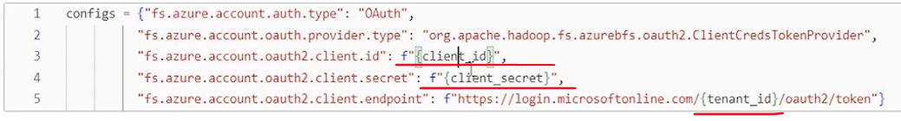

Once config is ready you can pass those configs to mount method. And mount it. So. But what do we want to mount? We want to mount, our storage account and container. Right. So for that URL you have to provide here, what is your container name. So let's put a variable substitution here also. And we already created container name here. Right. So. container name comes here. And then we also need to provide the storage account name. So let's put storage account name here. That's all. And what is the mount point? Mount point is always created in the dbfs root slash NT directory. That's a dedicated directory for user defined mount points. And you can give some mount name. So I already created a name here. what mount point we want to call it we call it files. So put a variable substitution here also. Right. So that's all. We are now ready to mount our storage account here.

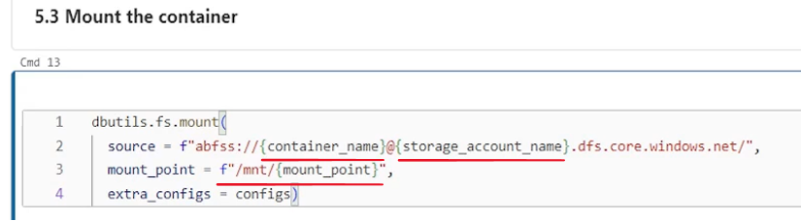

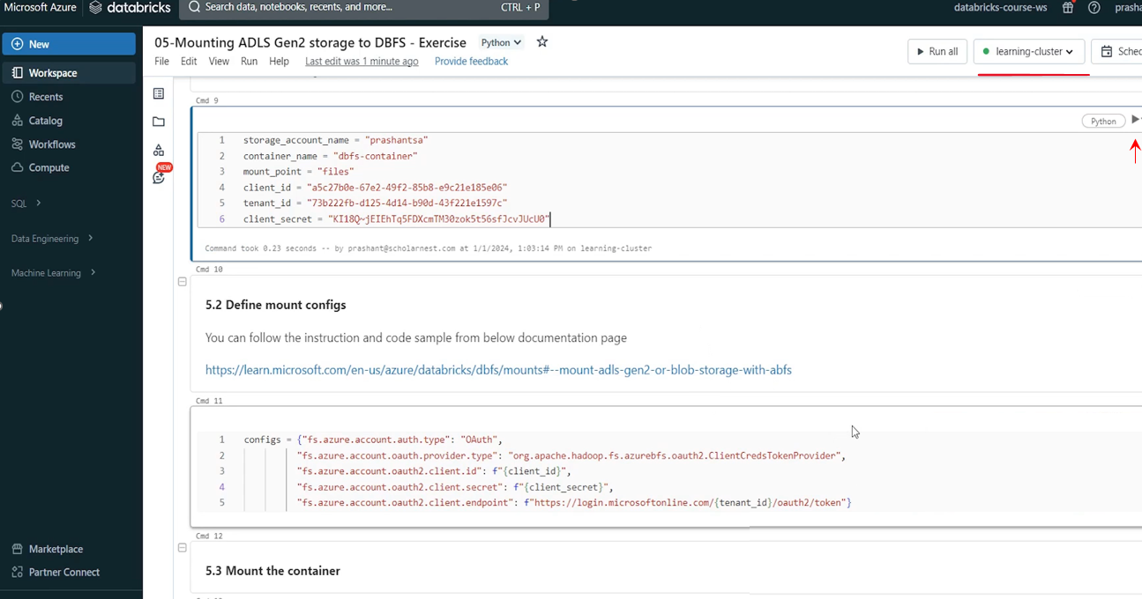

So what we are doing, we created a storage account in Azure and we created a user. We created permissions and we created granted access to the storage account for that user. Now we are mounting our storage account and container. With these configs. So we are basically telling Databricks. So this is the client ID. This is the secret you can use to authenticate from here. And once authenticated you can assume those user credentials like current client ID and secret ID to access the storage layer, my Azure storage layer from here and mount it to this place so that all users who have access to this workspace can access this mount point can access the storage layer. So let's run it. I have to. Connect my cluster for executing code in this notebook. Run the variable definition. Done. Then run the mount. Configs and then finally mount it. Okay. True. So it's successful now once you're.

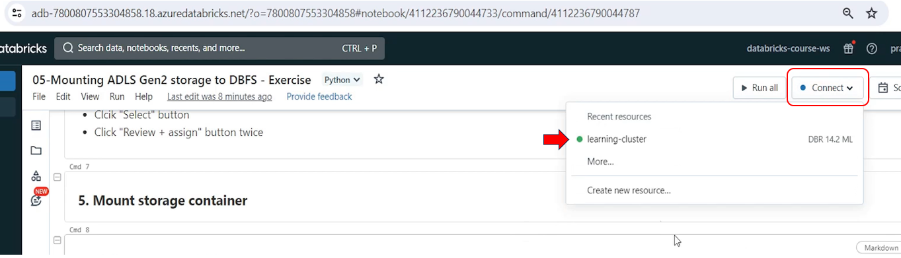

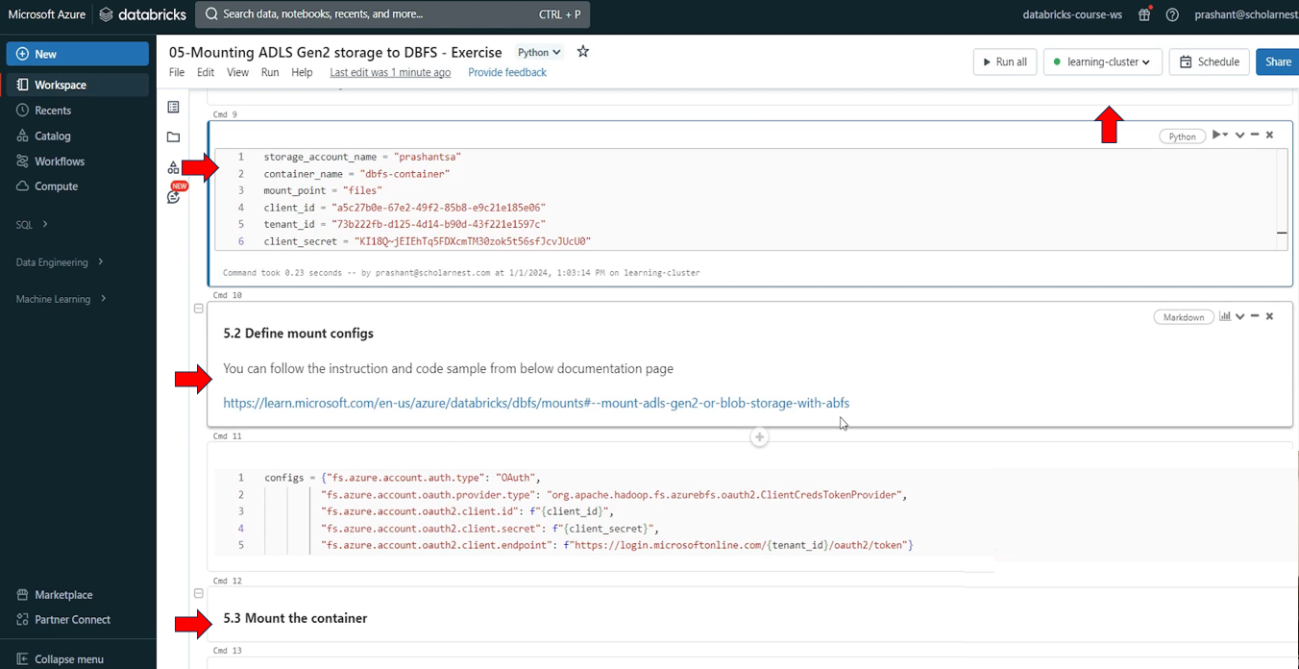

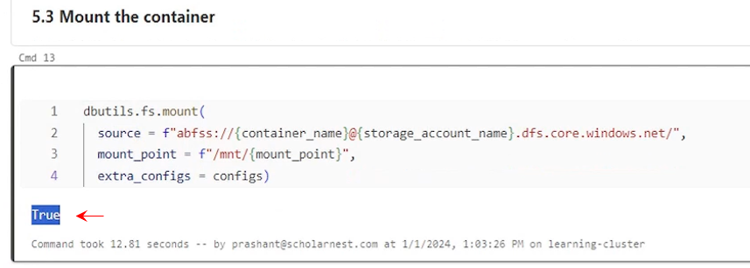

A storage account is mounted, right? You can. Check it %fs ls. We mounted it inside the root directory /mnt. Right. That's the mount position we used. and let's try to see, what is there inside the /mnt directory. And you will see files directory. Right.

|  |  |
| --- | --- |
| So that's a mount name right. Mount point is files directory here. But the actual container name behind the this mount point is dbfs container in this storage account. |  |

So you can see this, if you want to see what is there inside the files inside the mount point you can check that we don't have anything, so we will not see anything. It's simply okay.

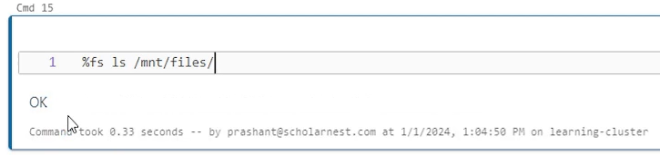

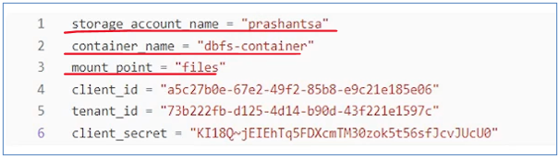

What if I already had some data files in this container?

Let's come here. come to my Home and then storage account and in my storage account and then inside containers. This is my dbfs container, right? Go inside the container. Maybe create a directory. Let's call it sampledata, right?

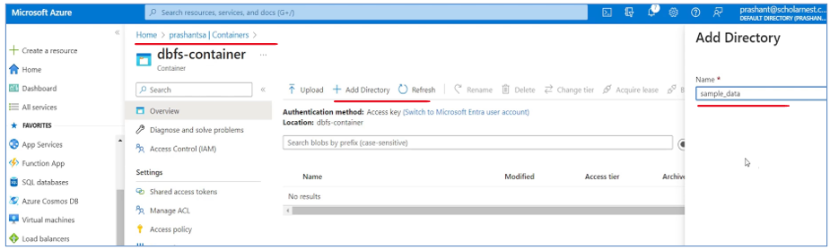

So create a directory from here and go inside the sample data and upload some data. So I'll drag and drop a data file here, so I'm dropped one people dot json data file here I hit the upload button and you will see a data file here. So basically I am in full control here I know what is my data storage account.

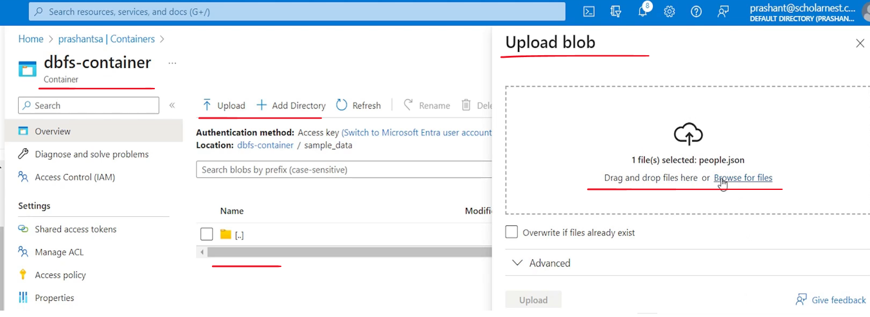

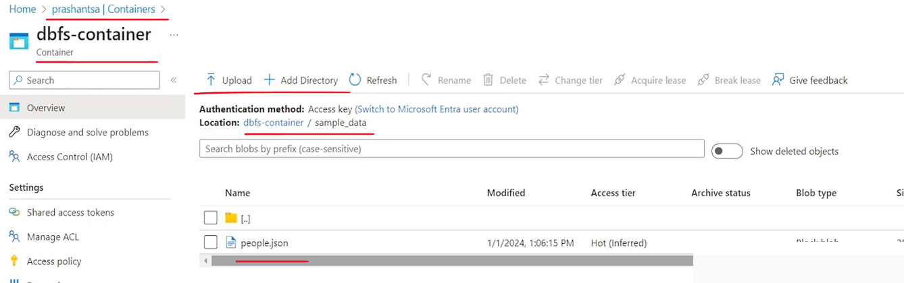

What is my container? Inside the container I have some data file. And once this data file is here, I can come here, upload the file to your mounted location. I have uploaded the file and list the content of your mounted location once again. So if you look at this, You will see sample data directory. So because I created it from back end from my Azure account, I could have created it from here also, but I've done it from the back end to show you that directory is the same, storage account is the same. You are accessing it from Databricks workspace after mounting it. So you create files and directories in that mounted location from Databricks Workspace or from any other tool from outside the workspace, directly from the Azure Cloud account or from your cloud account.

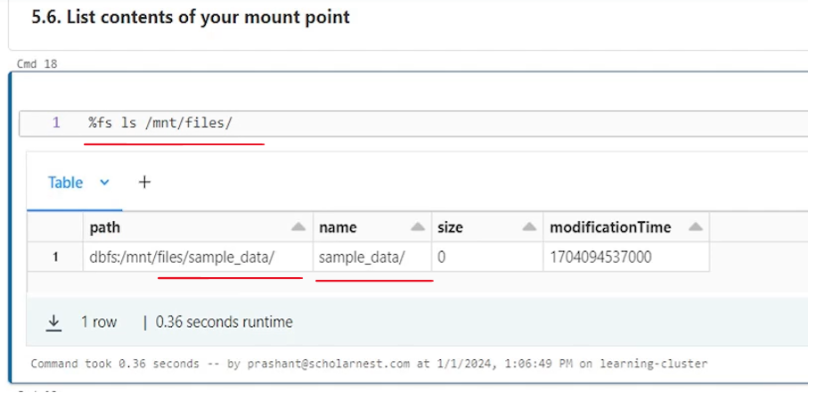

It's the same location. So whatever changes are made are visible here. So you can see the people.json, data file here.

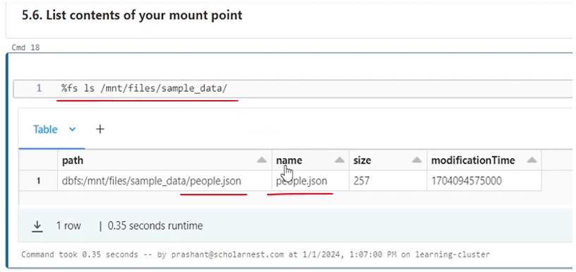

So we have the data file here, earlier we used one command percent FS mounts command to see all the mount points that we have or mounted directories we have in our dbfs root. So if you run the mounts you will see your directory also slash mnt files and it is mounted to this location.

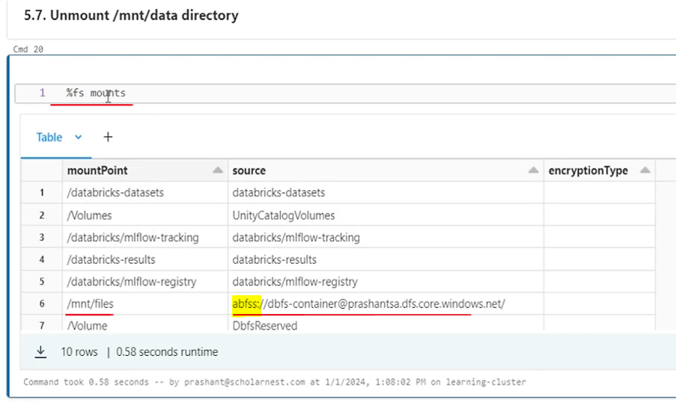

We can see here Azure binary or blob file system slash. This is my container name and this is my service account name and rest all are to point it to Azure cloud. Right. So that's what we have here.

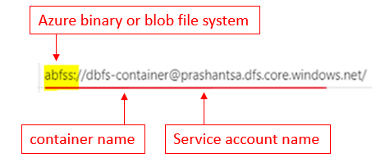

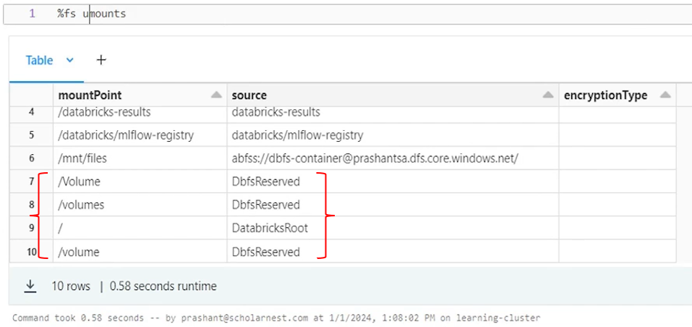

If you want to unmount it, maybe you can just run the unmount command and tell what you want to unmount. Let's say M and T and file. Right. This is what we mounted earlier. If you want to unmount you can use the unmount command and it will be gone. Let's let it finish. True it's unmounted. MNT files has been unmounted.

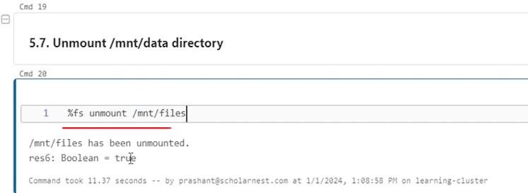

So now if you try to access the, MNT files directory. File not found. Exception. No such file or directory. It's gone. It's unmounted,

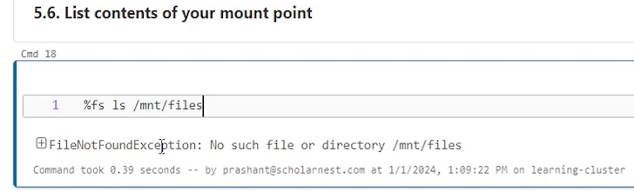

But it doesn't mean you lost your data, right? My data is still here. You can come to your Azure cloud, refresh it, go one level up in the container. I already have this sample data directory. you can come to back to Dbfs container. Right. You have the sample data directory inside this sample people.Json is already there. So your data is separate.

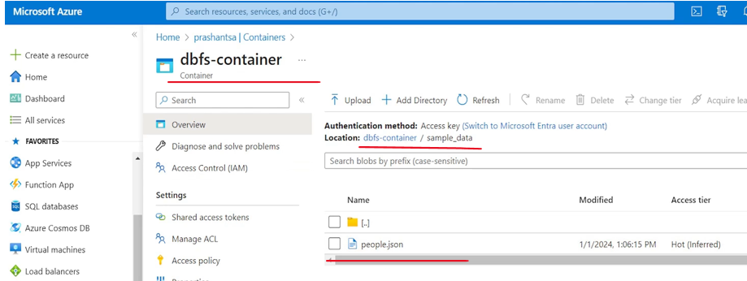

You want to use it on Databricks platform. you can come and mount it here. So if I run it again. The mount command or the mount API. I'll mount it again. So let it mount. And then. And once mounted, I can access it from Databricks. I can access that sample data directory, I can access the data file or whatever is there. Right? I can access it. It works completely perfectly.

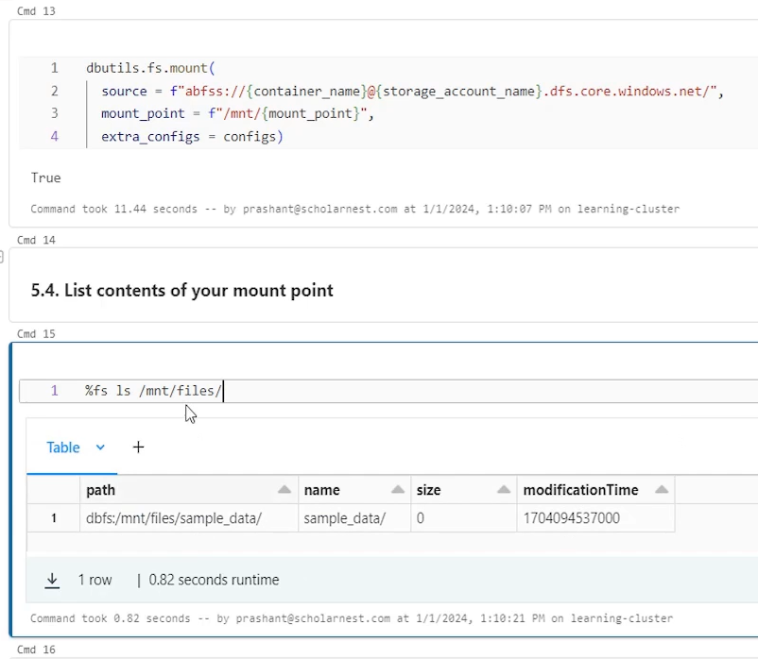

There are two problems here in this approach. We have mounted our storage account using Dbfs. The first problem is I am exposing all these details here. For example, I am exposing my client ID, I am exposing my tenant ID, and I am also exposing the secret key. It's like a password. So all these informations I am exposing in my notebook, if I keep this source code in the source control, anyone who has access to the source control can look at all these information. So that's the first problem.

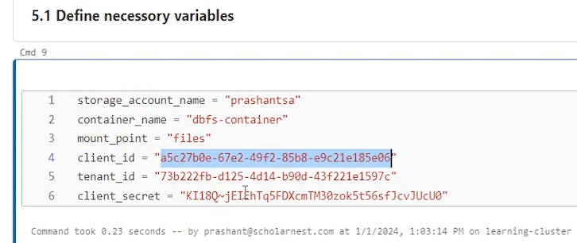

And we have a solution for this first problem. There is no big deal. Databricks gives you a approach to secure this. Right. So basically we can create Azure Vault in our Azure cloud account and secure all these in the Azure Vault and from Databricks, platform. From here, we can pull information from the vault instead of hard coding these secrets and these secret information for pulling details from the vault. we have this API here. Databricks dbutils.secrets. And from the secrets, we can get all the information. So that's how the documentation recommend. It's not recommended to hard code these things here. So that's but we have the solution. We can use the Azure Vault to secure all this. That's the first problem solution.

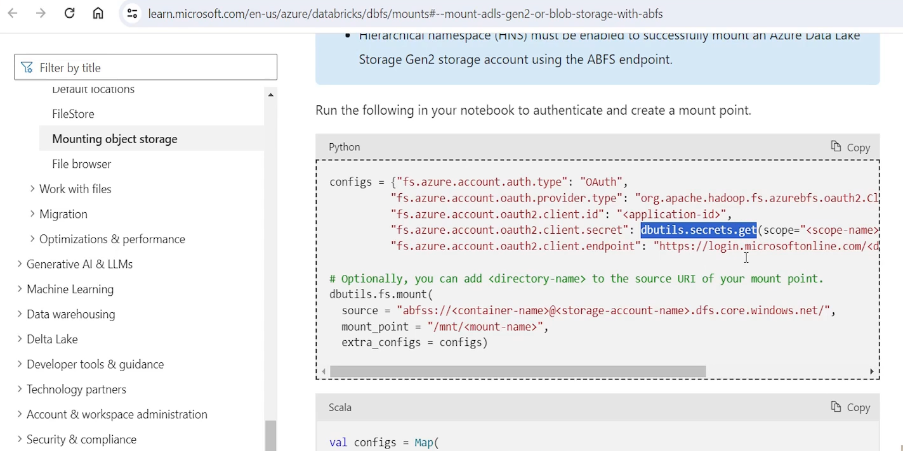

The second problem is once a directory is mounted right. Once you mount it this is. This directory, this directory location. This data set is available to all the users who have access to this workspace. Anyone who has access to this workspace can access this data.

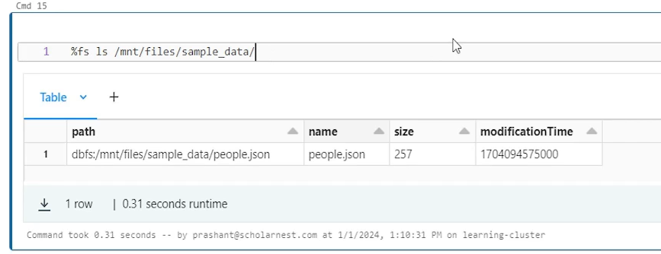



If you want to control that access, you may have to go back to your, Azure cloud and do a lot of things to control it. There is no easy way to control that. Some people will have access. Some people will not have access. Once it is mounted done. You have the access. Everyone who has the access to the workspace, they will have access to the data. That's the reason Dbfs is not a recommended approach for setting up your data directory

For setting up your storage layer for your lakehouse solution. We have different approach for doing that. And that's what we are going to learn in the next section. So keep that in mind that though we have dbfs Databricks File System facility here, it allows us to mount your storage account and container from your cloud storage and use it for storing your data. But that's not the recommended approach. We don't use it due to lack of fine grained access control capabilities.

## Databricks Cloud

|  |  |  |  |
| --- | --- | --- | --- |
|  |  |  |  |

We have seen how to create Databricks workspace, how to use Databricks Workspace notebooks, about Databricks File System Dbfs. We also learned that we can mount our cloud storage layer or cloud storage solution into the Dbfs so that we can store our data there. However, Dbfs is not a recommended approach for setting up your, storage layer for your lake house or for your data lake projects. So how do we go about it?

We will introduce you to the metadata management in Databricks Cloud. And we will also learn user management in the Databricks Cloud Platform. And we'll go through the fine grained access control. With all this we will also learn how to set up your storage layer in the cloud for your Databricks Lake House or data lake projects and all things together combine, and we get a complete solution on setting up a storage layer, managing metadata, managing users, and handling fine grained access control.

First we get an introduction to the unity Catalog. We will try to understand what is Unity Catalog. What is metadata management solution in Databricks Cloud. And then next we will learn how to set up Unity catalog. Basically we will set up a storage layer for our, lake house or Data Lake project. And on top of that, the storage layer. We will set up Unity Catalog to manage all the metadata, to manage all the user accounts and handle fine grained access control through the Unity catalog. And finally, we will see some demos on how to secure objects and how to give fine grained access control for your, data objects.

### Databricks Unity Catalog

Lets understand what is Unity Catalog and what are the features and capabilities that are offered by Databricks Unity Catalog. So here is a diagram that represents everything that Unity Catalog has to offer.



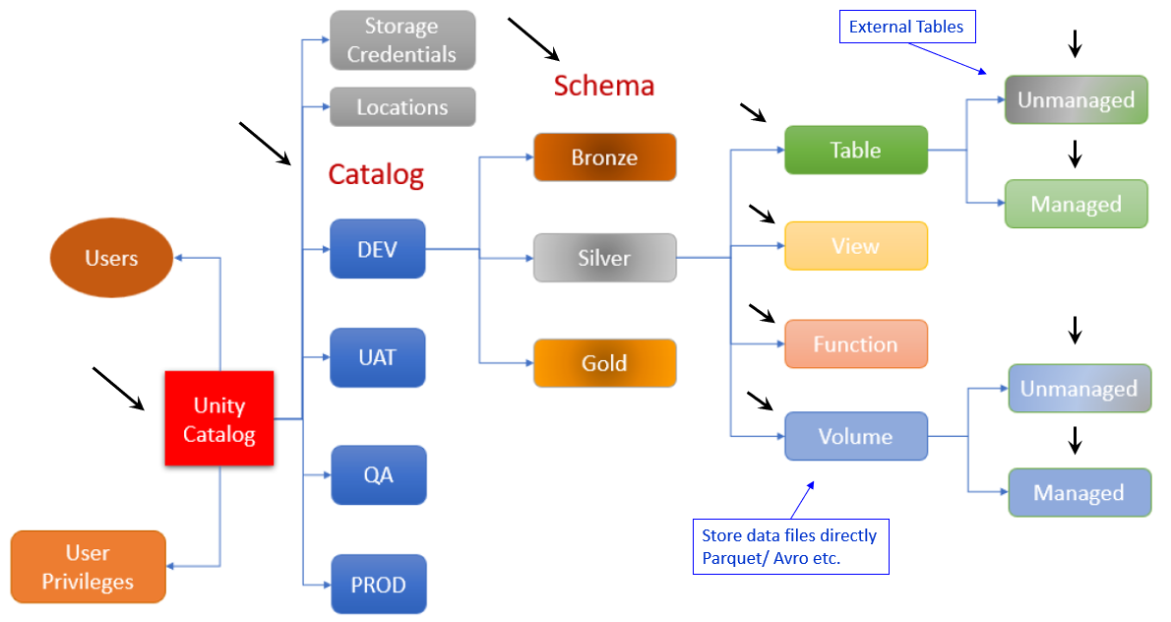

So let's start with this box in the beginning. This is your unity catalog. Or you can say your metadata store or simply meta store. So in Databricks we use Unity catalog as a metadata storage. Or for storing all your metadata, all your project metadata. So within Unity Catalog Metastore, you can create catalogs. The first level of object that we can create inside the unity catalog is known as catalog.

These catalogs are to separate out things. You can create catalogs based on your project. Like you can have project one catalog, project two catalog, project three catalog – so one catalog for each project. Or simply you can create multiple catalogs for your environment. So I have taken an example for the environment. So let's assume for one project you have three-four environments like you have dev environment, you have UAT environment, you have QA environment and you have prod environment.

So within the unity catalog we can create separate catalogs for each environment. And within each catalog you can create your databases. So let's take example for the dev catalog. And same things can be repeated for UAT, QA and prod. So within the dev catalog means your dev environment. You can create databases in Databricks. Databases are also known as schema. Schema and database, these two terms are synonyms in Databricks. So we call it schema or we call it database, both are the same. So within dev catalog you can create as many databases as you want.

For example you want to implement medallion architecture. So you might want to create three databases bronze database, silver database and gold database. And within each database you can create the actual data objects. For example, within the silver I can create tables. I can create n number of tables. Within the silver database I can create views, I can create functions, user defined functions, and I can create volumes. So these are four types of objects that are supported inside the schema.

So I can create different types of objects. I hope you already understand that tables are of two types in spark unmanaged tables or external tables. And then managed tables. So you can create unmanaged tables. You can create manage tables. You can create views, you can create user defined functions. And you can also create volumes. Volumes are also two of two types unmanaged volumes and managed volumes. Tables and volumes are two types of objects to store data in. In real sense. You can store data physically inside these two types of objects. In tables. Your data is stored in the tabular form in as a table. So you will have some table metadata like what is the table name? What is the columns in that table, what are the data types of all these columns. And you can load data or insert data into those tables. But data is physically stored in data files behind those tables. But when you want to access them you access them through the table name, through the table volumes are another type of, data storage objects, which allows you to store files, data files, directory directly.

So within a volume you can store data files. It it is not like table. You don't need to create tables. You can simply store your data in files. Why? We have two types of objects tables and volumes. Because spark supports storing data in form of tables and in spark also supports working directly with the data files. You can save data in parquet file or CSV file, or maybe in Avro files, so you can directly save data as files. You can directly read data from files. So if you have that kind of requirement where you want to directly work with the data files, not with the tables, you can use volumes. So you can create volumes. And inside volumes you are allowed to save data files directly. And these are also like tables. These are also unmanaged and managed. Same idea works here for unmanaged volumes. If you delete the volume, spark will delete only the volume metadata and will leave the data files as it is with the managed volumes. When you delete the volume, spark will delete the metadata. It will also delete the volume directory where data is stored. All the data files are also removed, so same idea like unmanaged tables and managed tables also extends to the volumes.

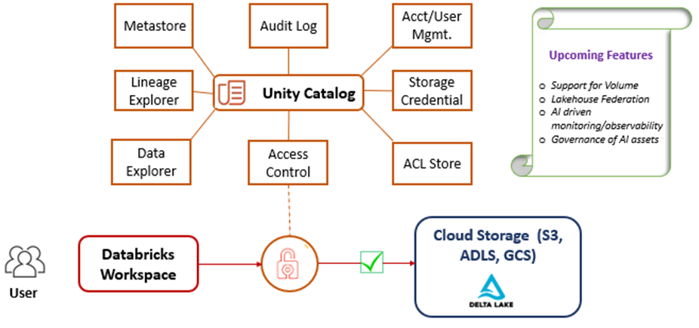

So in Unity Catalog or in Unity Catalog Metastore we can create different catalogs within catalogs. We can create a schema or databases. And within a schema we can create tables, views, functions, volumes, all that we can create. Other than that. Unity catalog also allows you to create locations or we sometimes call them external locations. These are nothing but directories. We learned about Dbfs, right? So we in Dbfs we mounted directory, the cloud storage container as a directory on the Dbfs. Right. Similar things can be done with the unity catalog. You may have a cloud storage layer where you created some container, and you can bring that container inside the unity catalog management space and create external locations or locations. And once these locations are created, you can use them like directories in your unity catalog managed directories. And for accessing these directories you will need some credentials, right? Without having a proper cloud user or a service account, with the appropriate permissions to these locations, you cannot access them. So for that you can also create storage credentials. And these storage credentials are also stored in the unity catalog and managed by Unity Catalog. So these locations can be accessed using the Unity Catalog stored storage credentials.

So these together gives you an approach to define or map your cloud storage layer with the unity catalog and use it for storing your data or for whatever purpose you want to use it, instead of using dbfs mounts. Right? These are the alternative solution for that. So all these things that you see here on the right side of the Unity catalog, Metastore, all these things can be secured and they allow fine grained access control. What it means, it means simply you can grant permissions on all these type of objects from the unity catalog itself. for granting permissions, you will simply use Grant command SQL grant command so you can give grant, select grant, use grant update or those kind of grants. you might have already learned simple SQL grant commands and SQL revoke commands in any database. Right. So same idea is used here.

All these objects are secure able with grants and revokes and privileges and even including these storage locations. So you can give grant, read only permissions on these storage locations or tables or volumes or views or on functions to a user group. Right. And you can give a different, more advanced privilege like read write privilege on these objects to another group. So all that can be done. And for doing that unity catalog also needs to manage user accounts. Right. So within the unity catalog meta store we also store all the user accounts. we usually import the users from our Active Directory or from Corporate Active Directory. We bring those users into the unity catalog. Or you can also create users directly in the unity catalog. But most likely you will bring your existing enterprise users into the unity catalog. You will import them or you will sync them into the unity catalog. So once users are there in the Unity Catalog, Metastore, you can also, grant privileges, different kinds of privileges, and all those privileges are also stored in the Unity Catalog. Metastore.

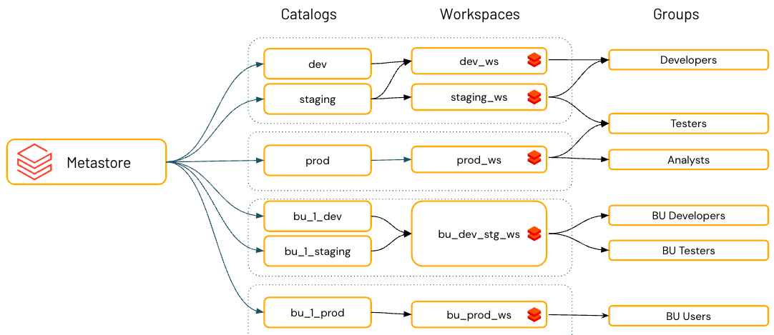

So Unity Catalog is a complete solution for metadata management, for user management, for access management, fine grained access control. Everything is done through the unity catalog for your entire project, for all your environments. If you have multiple environments, it can be done for all the environments at from one centralized unity catalog, instance or unity catalog setup. It can go even across, projects. So you can create multiple catalogs for each project and for multiple projects. Also, you can have one single unity catalog, instance, which is, managing the entire object, metadata, users and privileges together from the single centralized unity catalog place. So it's up to you how you want to set up in your project, but bare minimum is for an entire project. We should have, Catalogs for different different environments and manage the entire metadata for the complete project from a central Unity Catalog instance. So that's about the unity catalog. Introduction. How to set up Unity catalog, how to set up tables, views, functions, volumes, your locations, storage credentials, how to create catalogs, how to import users, how to give privileges.

### Setup Unity Catalog

Let us recall the medallion architecture or lake house medallion architecture.

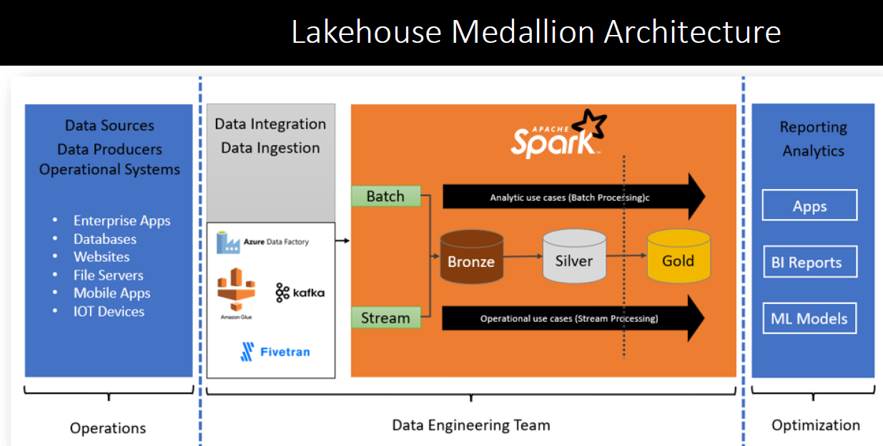

So in data engineering projects, we aim to solve the problems, data engineering problems using an appropriate data engineering project architecture. And in modern days, lake house medallion architecture is the most widely adopted architecture pattern. In this architecture pattern, we ingest data either in batch or in stream. Bring it to our bronze layer, which is our raw data storage and store data here. But where is your storage layer? Where this data goes? Where do we keep the data in tables or in files? How do we manage metadata for, those data sets, all that needs a proper infrastructure design and setup. And we need to use some technology or tool for doing that.

|  |  |
| --- | --- |
|  | Similarly, once your data is in the bronze layer, you start implementing your data transformation, data quality, data processing logic and start preparing data for your end consumers. And all those can be done in multiple stages or in multiple steps. The usual idea is to read data from raw data from the bronze layer, create a bunch of intermediate tables or your high quality data tables. Keep them in a separate layer. We call it silver layer and then use those silver layer tables to prepare the final results for your consumption. So all this could be multiple databases or multiple layers. |

But in all these layers you need to store a lot of data. So how do you store that data. Where do you store that data. So for storing data and managing the entire data with a proper metadata and proper access control, privileges all that we need to design this thing. So how do we design that using data bricks. So here is the diagram that represents how we design the Lakehouse platform using the Databricks Cloud Environment or Databricks Cloud Platform.

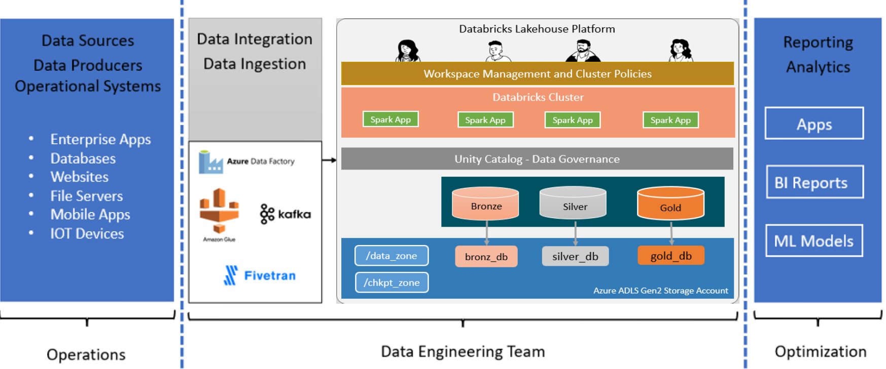

So if you look at this part this part represents a typical platform architecture for a lake house project or using lake house medallion architecture pattern. And this architecture is also designed in multiple layers. At the bottom this blue box is your storage layer, the physical storage layer. Usually, if you are working in Azure Databricks or you are in the Azure Cloud Platform, this physical storage layer is created using Azure ADLs storage account and a bunch of ADLs storage account containers. So this is your actual physical storage where data will physically go and sit in form of files. So for that we have to set up one Azure Storage account. And within that account you can create one or more containers. So all these boxes that you see are actually containers and data will actually come and sit into this containers. On this physical storage layer we can have multiple, one or more logical storage objects. And these are nothing but your databases or, within the databases you can have tables or volumes. So these are logical layers. Or you can have external locations, where you directly write data in form of file. All that is your logical storage layer.

So we need to design a physical storage layer. Then on top of that we need to create a logical storage layer. And all this logical storage layer is managed through a data governance solution in Databricks. That data governance solution is Unity Catalog. So on top of these logical layers, we will have a unity catalog layer and any user or application, let's say you have a spark application which needs to read data from. This physical layer will come through the unity catalog, will have to pass through the unity catalog and then access the logical layer. And internally it will read data from the physical layer. Similarly, let's say you have a spark application which wants to save data, Produce the output. So for saving and producing output also your spark application will pass through the unity catalog and then behind the unity catalog, it will come and access the logical layer of your data and save data in the logical layers. But internally it is saved in the physical layer. So all the access, all the spark applications that are running in your Databricks cluster will have to pass through the unity catalog for accessing the data, for reading data and for writing data. And that gives us an opportunity to set up a fine grained access control here. We can, grant privileges, we can restrict access, we can do all kind of fine grained access control management from the unity catalog itself. That's where Unity Catalog fits in.

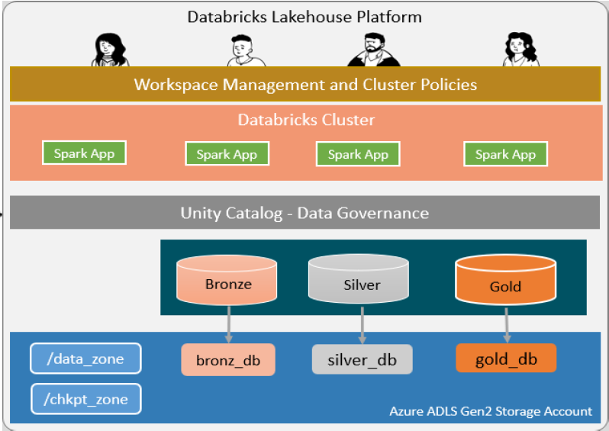

So, on top of the unity catalog, we will have Databricks clusters. In the clusters. You will have your applications running or application code or notebooks running. And these notebooks will pass through the unity catalog to access the data. But for creating clusters, running applications, or deploying your applications, you will have to come to the workspace, right? Databricks Workspace and Databricks Workspace is the place which where you your end users or developers or QA people or your team, can work. So your team is sitting at the top. They access this entire stack through the workspace, and the way to access things are to create clusters and run your code in the cluster. And ultimately, that code passes through Unity Catalog to access the data. So that's how we design the Medallion architecture platform for our project using Databricks Cloud technology or Databricks Cloud Platform.

|  |  |
| --- | --- |
| The idea is to set up a unity catalog or data governance layer for our project. Setting up Unity Catalog and your storage layer is a two step process. The first step or first part is done from the your cloud provider. In our case it is Azure. So first part of it should be done from Azure. The second part is done from the Databricks Workspace environment. So before you start setting up your unity catalog or your data governance layer or your storage layer for your project, you should already have at least one Databricks workspace, because half of the activity is done from the Databricks Workspace. And Databricks Workspace should be premium Databricks workspace. In a standard workspace, lot of features are not available, so I already have both the things, we created a Databricks workspace and I have access to my Azure Cloud account. |  |

So let me open my workspace. I have documented step by step process for setting up your storage layer or your unity catalog metadata layer, and we will follow through the list, in my workspace in my notebook.

So in my home directory. In my workspace in the home directory. in chapter six, I have unity catalog setup notebook, and this notebook documents the entire process. So setting up Unity catalog is a four step process. The first thing you need to have a workspace. So create a workspace I already created a workspace. I already have this Databricks course workspace which is a premium workspace. The second step is to create data storage layer. This is done from the Azure cloud because physical data should be stored in your cloud storage layer. We will go through this step and third step. Once you set up your data storage layer you have to set up Unity catalog Metastore. That is done from the Databricks workspace.

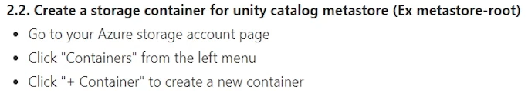

And then finally you can set up users and permissions. You can import your users from Corporate Active Directory and then start setting up permissions for your users. So first step is already done. We will start with the second step - create data storage layer. First point is create a storage account. So let's go there in my Azure. And I already created a storage account here. The storage account name is prashanth-sc. I created it in the earlier lecture. So we will reuse the same storage account. There is no need to create a separate storage account, but if you want you can create a separate one.

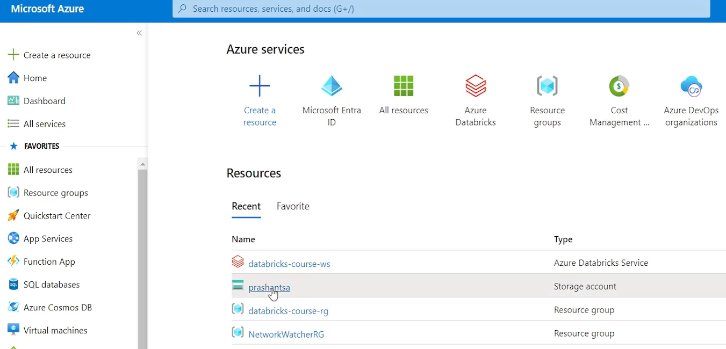

Third thing is we need to create storage containers within this storage account. So details are listed here. Create a storage container for unity catalog Metastore. Container name could be anything. I want to keep it meta-store-root. So go to your Azure Storage account page. Click containers and create a container. I'm already into my storage account page and let's go to containers menu.

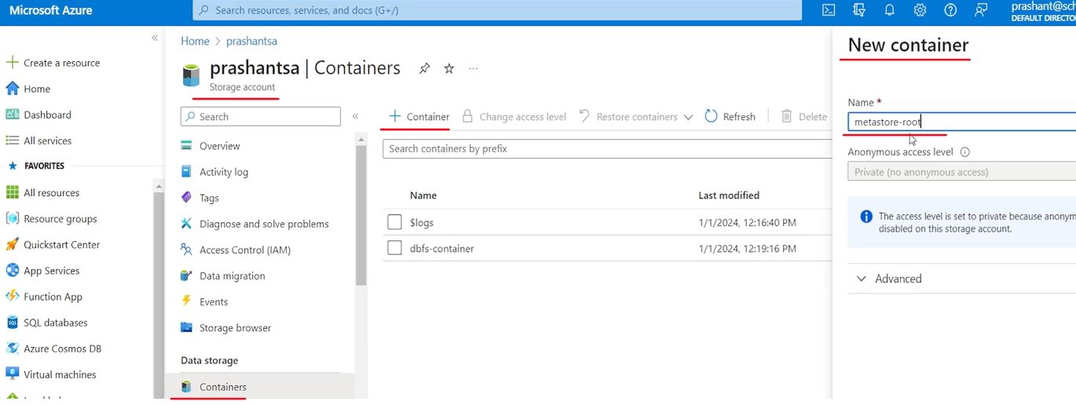

We did it in the earlier lecture also and created Dbfs container here. For now let's create a new container for our unity catalog. So let's call it, Unity Catalog Metastore root or simply Metastore root. And that's all hit the create button and. It should be created within a second. So I have the Metastore root storage container already created. Let's look at what is the next. So I have the storage container.

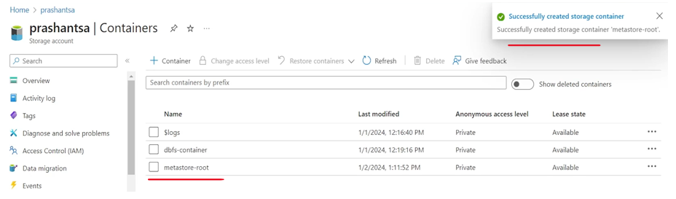

Now next step is to create database access connector. In earlier lectures we created a Service principle to access the storage. But in this case, for working with the meta store or working with the unity catalog, the idea is to use a connector. And that connector, comes with some security credentials to access your storage container. So we will create a connector. And here is the steps, to create a Databricks access connector click + Create resource button on your Azure portal and search for Access connector for Azure Databricks. So let's go back to our portal. On home page you can find the Creator resource link here or here.

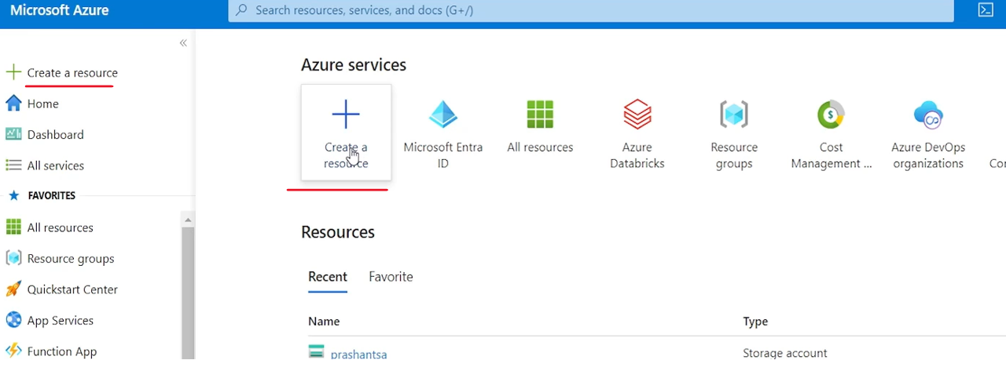

Let's go with this and search for Access Connector for Azure Databricks. Let's choose this and you will see something like this access connector for Azure Databricks.

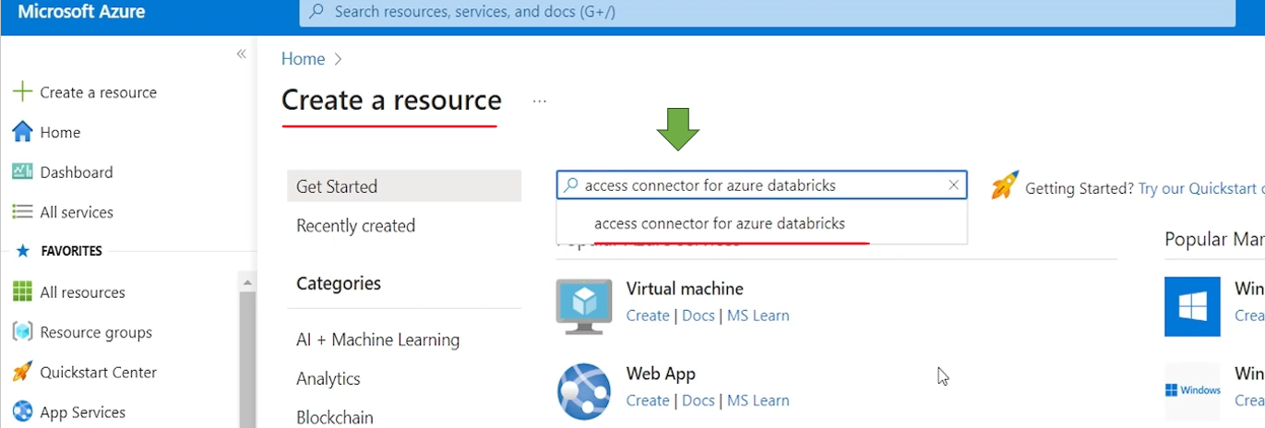

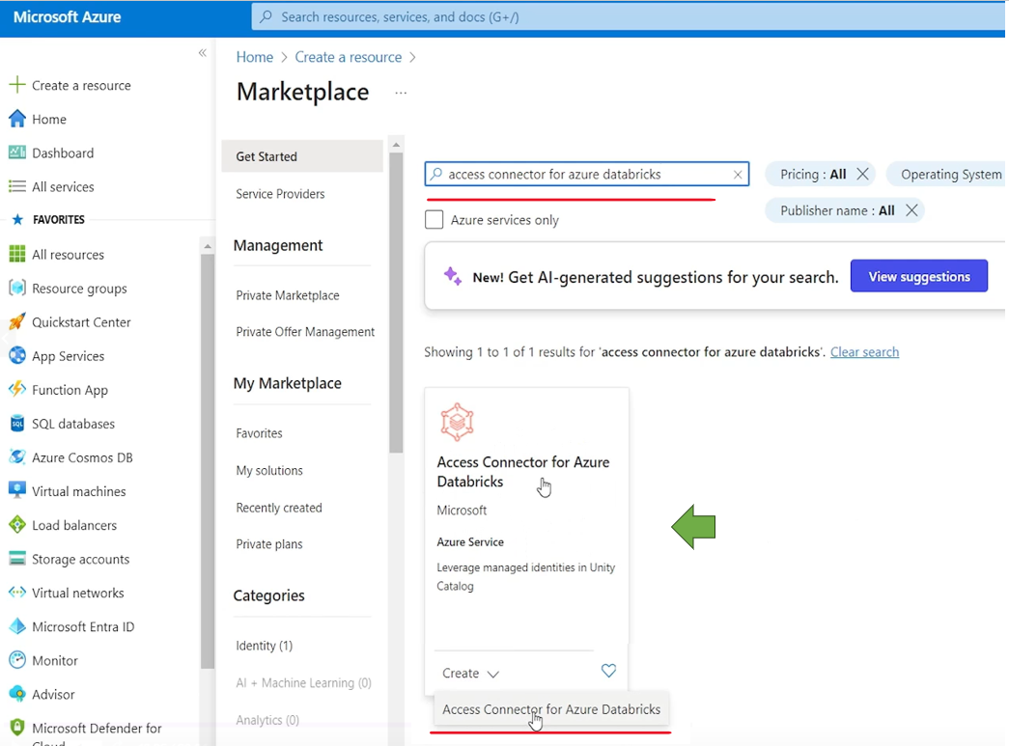

Let's hit the create button access connector for Azure Databricks.

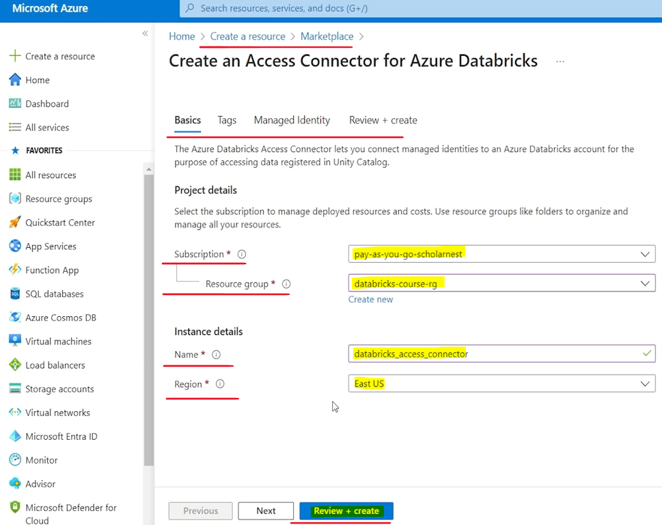

And like any other resource in Azure we have to define few things like, what is the subscription? What is the resource group you want to group this resource?

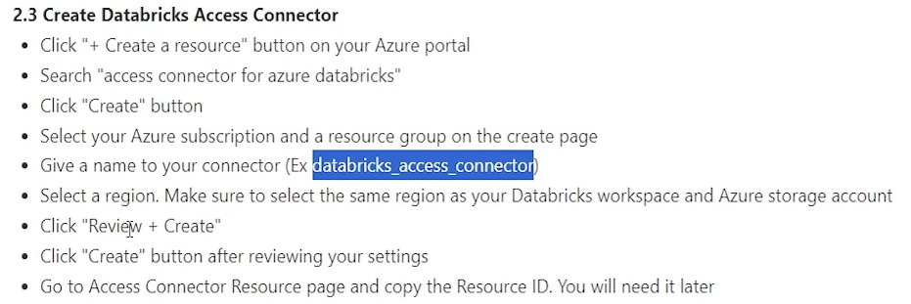

We already created a resource group for this connect this course. So let me use the same resource group so we know everything into a single resource group. And then let's give a name for your connector. So let me copy the name. What connector name we want to give. We want to call it Databricks Access Connector. So let's give the same name here. Databricks Access Connector and region is US East. There is a particular, reason why we choose this US East region. Because Databricks workspace is in US east and storage account is also in the US east. So we keep the same region for the connector. And let's see what we have next. select the region and just review and create. There are few other things that we, can select here, but for now we can go with the default. Let's hit the review and create button. Azure will validate it. And once it is validated we will see a create button enabled. Let's hit the create button.

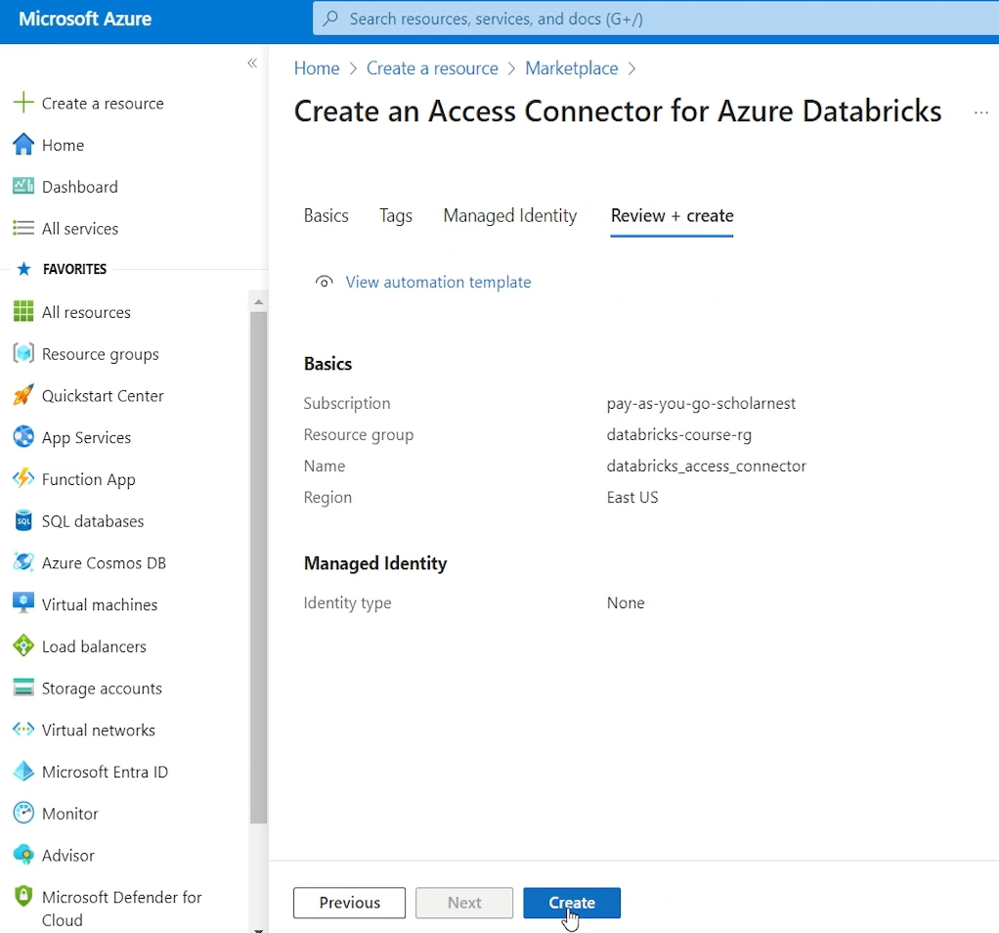

And in a couple of seconds it should be done. Or maybe taking longer. So let's review our steps. Select a region, click review and create button. Click create button. For reviewing your settings, go to Access Connector Resource page and copy the resource ID. You will need it later. So my access connector is done. Deployment. Successful I can go to resource from here itself or it should be visible in my home page also. Yeah I can come here and maybe. It's not visible here, so I can see all resources. And I can see here Databricks access connector. So you can come to the Databricks Access Connector page, from various places.

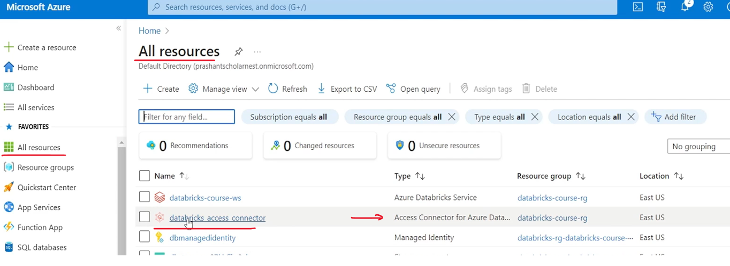

So I am on my Databricks Access Connector page. What is the ask? Copy the resource ID, you will need it later. So this resource is created and here is the resource ID So let's copy it and keep it in some notebook. You will need it later. I can come back here and copy it again, but let's copy it. so I don't have to come back here again. So we created access connector.

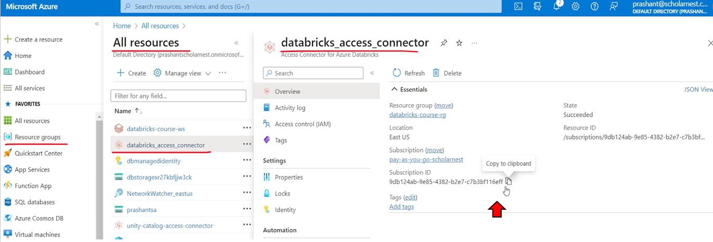

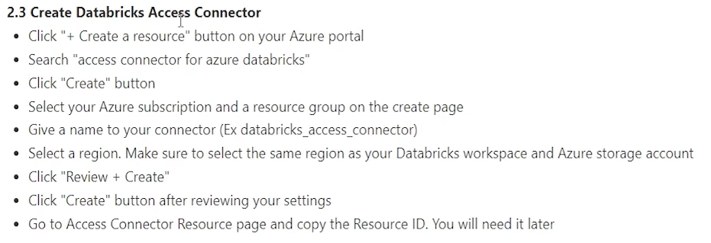

What is the next step? Next step is to grant access to the access connector for your Azure storage account.

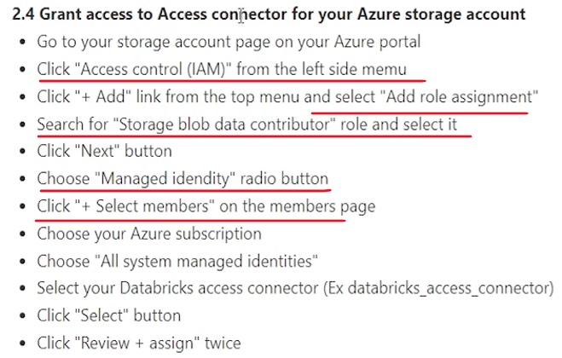

So this access connector will be used for reading and writing data into my storage account, into my Azure storage account. So we will have to grant that permission to the connector. So next step is go to your storage account page on your Azure portal. So let's go to home find my storage account. Here it is I am on the storage account page. Now click Access Control. IAM from the left side menu and click Add Link from the top menu and select Add Role Assignment. So I'll come to Access Control IAM page add link add role assignment. What role do we want to grant here? Same. We did that same role while trying to mount the, container into Dbfs. Same kind of role is required here. So we select this and maybe click next and click next and choose Managed Identity Radio button and then select members.

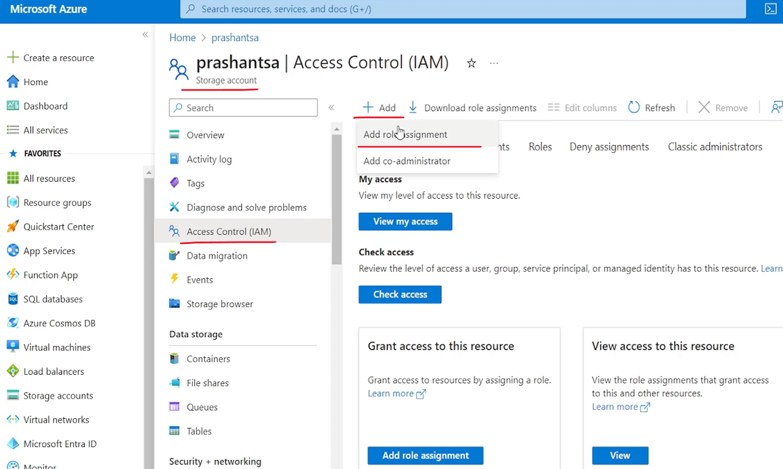

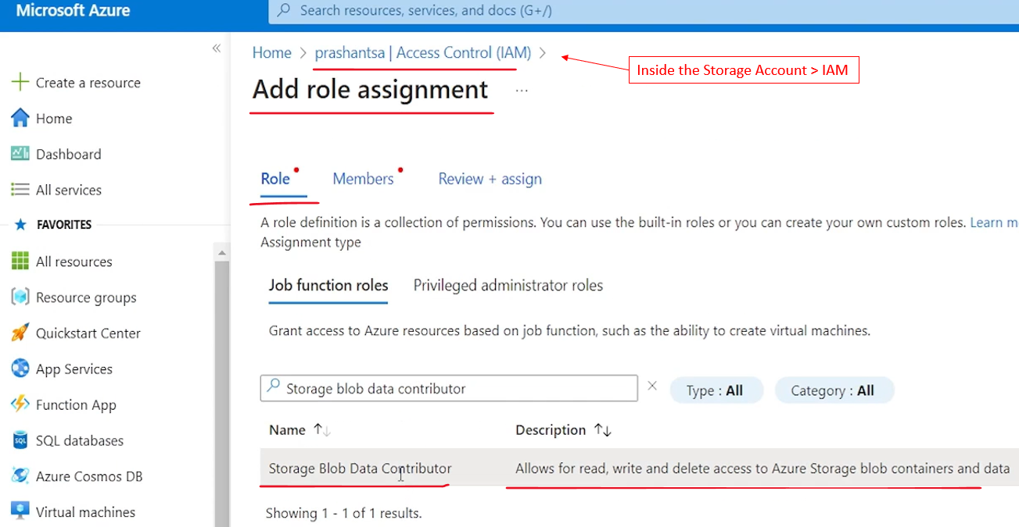

So we don't want to grant this to a user or a group or service principle. In the earlier scenario, we created a service principle. And given that, role to the service principle. But this time we are creating a connector which is a managed identity, Azure managed identity. So we go with the managed identity and select members, in your subscription, try to find the managed identity. Let's see all system assigned managed identities. You can cross check your resource ID and choose the appropriate one. So I'm selecting this access connector and that's all select. And you will see it is shown here.

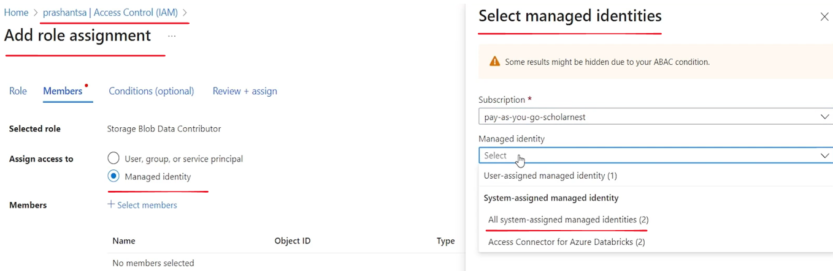

Choose your Azure subscription all system managed identity. Select your Databricks Access connector. This is the name that I gave when creating the connector. Select review and Assign twice. So review and assign and then review and assign once again. And it's adding role assignment for the connector. Added.

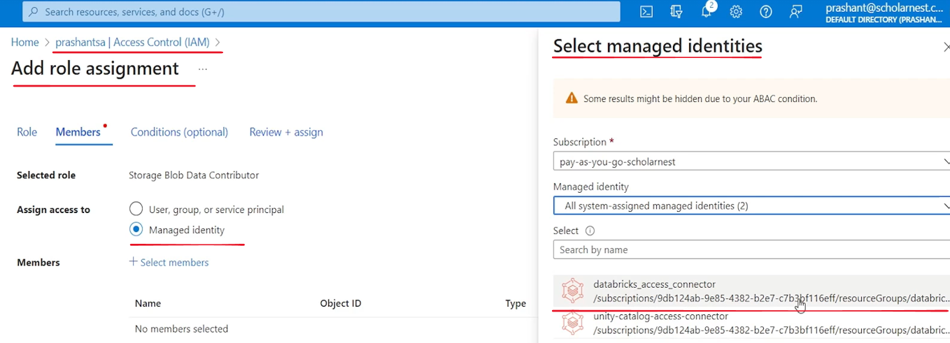

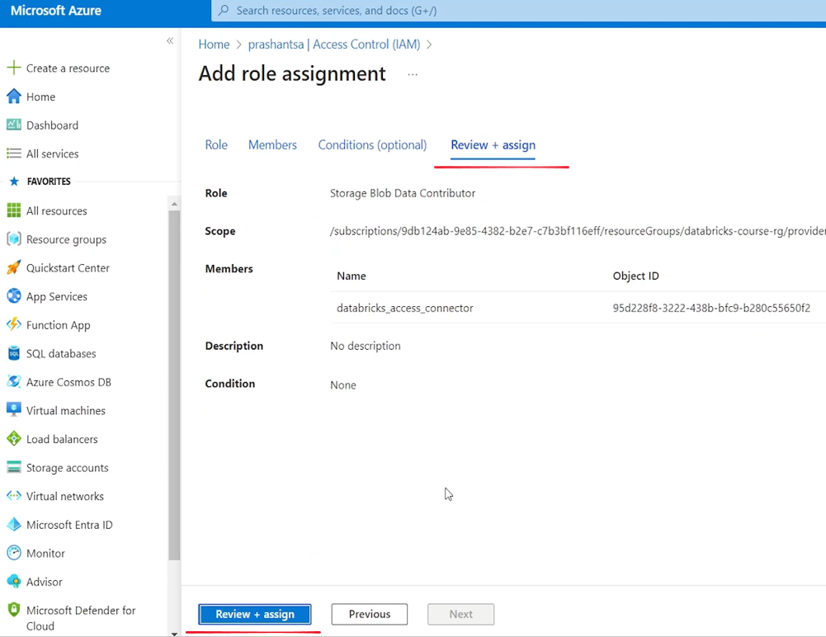

So step 2.4 is also done. Grant access to access connector for your Azure storage accounts.

The next step - step three is set up unity catalog Metastore. So we are done whatever we wanted to do from the Azure portal side.

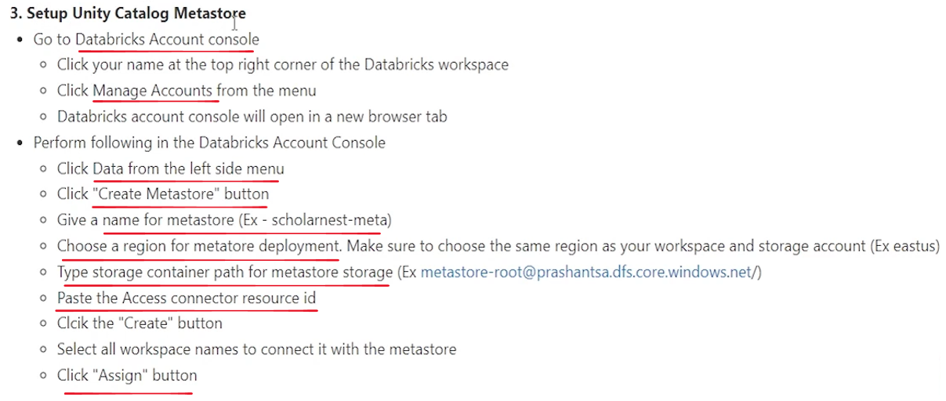

What we did so far is

1. We created a storage account.
2. We created a container where all the unity catalog metadata will be stored.
3. We created a root directory for unity catalog.
4. Then we created a connector which will have access to the storage account.
5. And then we gave a role, account storage account contributor role to the connector.

So we are set up from the Azure Cloud account. And now rest all we can do from the workspace itself, Databricks workspace itself. So go to your Databricks Account Console. So here it is, this is my Databricks workspace.

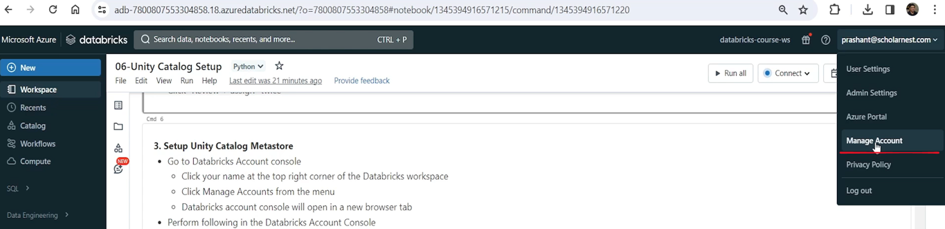

In the workspace you can click this and you will see Manage Account. You will see this menu option only if you are an admin for this account. not all users will have manage account access. So let's click the manage account. I am the admin for this entire Databricks, account service because I created it from the Azure account right from the Azure cloud I created that. So here is the Databricks account console.

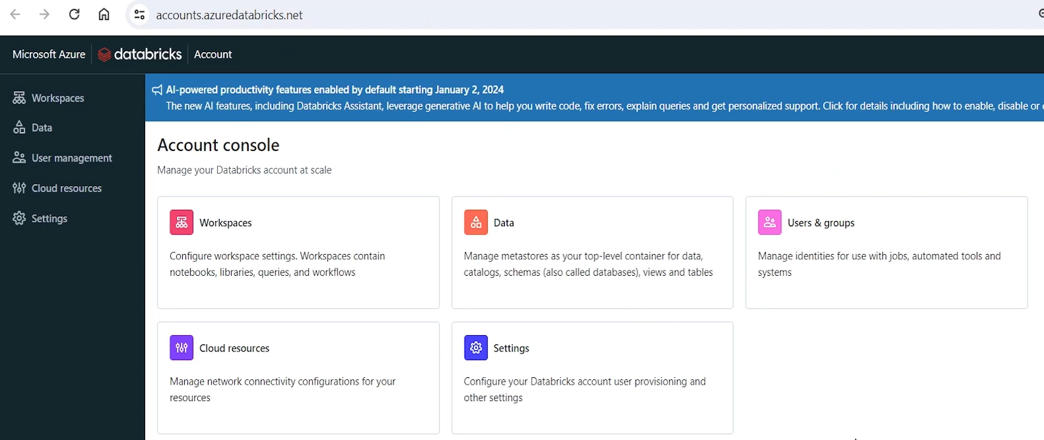

I came here from my workspace following this manage account link. Remember that this is known as Databricks Account Console. So what is the next step? click your name at the top right corner in the Databricks workspace. Click Manage Accounts from the menu. Databricks Account Console will open in a new browser tab, so we are done with that. Perform following in Databricks Account Console. So what do we want to do there. Click data from the left side menu. So let's click data. So I am in the data tab in Databricks Account Console. Click create Metastore button and give a name for your Metastore whatever name you want you can give, let me call it is scholarnest-meta and then choose a region for your Metastore deployment.

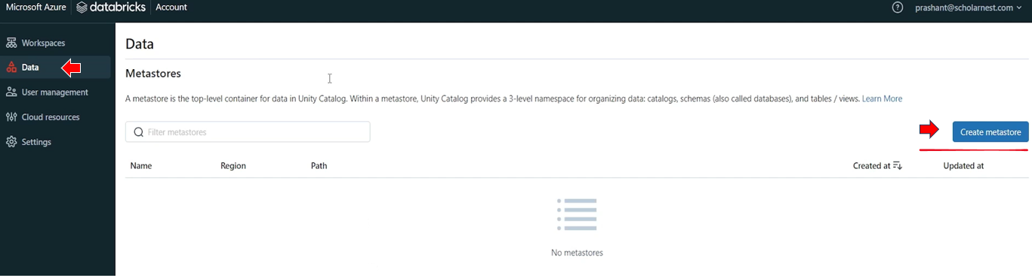

Make sure to choose the same region as your workspace and storage account. Example East us. So let me go back to my account console. I have Chris create metadata create meta store. So what I gave a name is called Nest Meta. So what we are doing here we are creating a meta store. A storage for Unity catalog, where Unity Catalog will store everything, including metadata and other things whatever Unity Catalog needs to store.

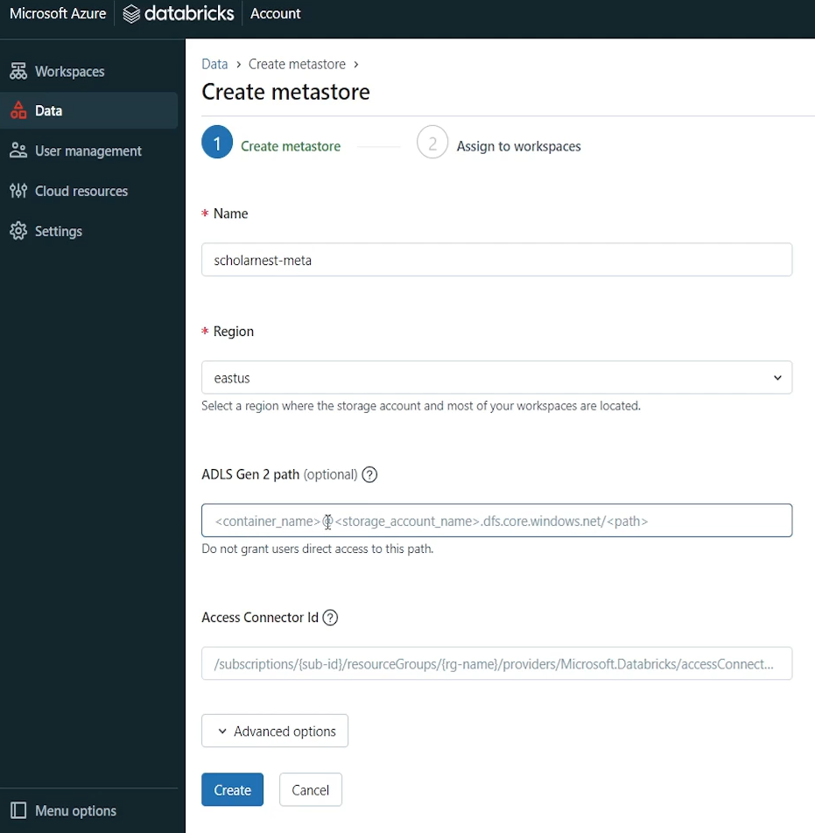

So choose a region. A region should. There are all regions listed here, but we are in the East US region. I've created my workspace, my storage account, everything in this same region. So let's go with the same region. Our next step is to tell ADLS Gen 2 path. So what is the Azure Data Lake storage container that we want to give to Unity Catalog for this metastore. We already created a container here. if you come to storage, look for container. We created this meta store root container here so we can provide all those details.

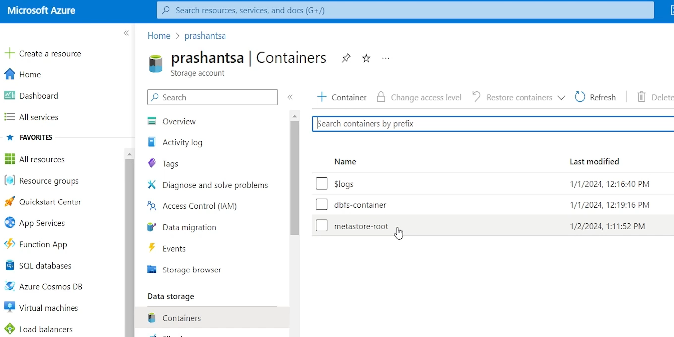

But remember the syntax it's container name at account name dot DFS and all that. So let me paste the URL. I have already prepared the URL using these guidelines. So here it is. So container name at storage account name.dfs.co dot windows dot net and root root. I'm saying slash just because I want to use this entire container as the storage for this meta store. It is also possible that inside this container I create a directory and I can go inside the container, add a directory here and then instead of giving the entire container to Unity catalog, I can give only one directory in that container I can post, put something like, meta store here, which is a directory inside the container. But it's good to give the entire container to the unity catalog and do not mix in things in the same container. So keep it separate. So that's done. next is to provide access connector ID and URL should be like this. So basically it is the resource ID of your access connector.

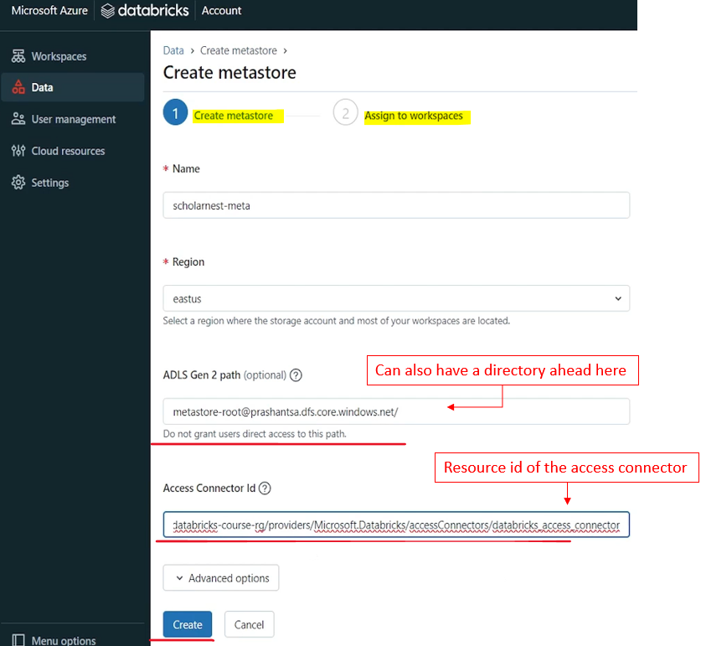

We created Access Connector earlier. You can find it in all resources. Databricks Access Connector and resource ID is visible here. We copied it earlier, lets paste the details here, and that's all. Let's look at the steps, paste the access connector resource ID, hit the create button and then let's see what comes up. So hit the create button and Databricks will create a Metastore.

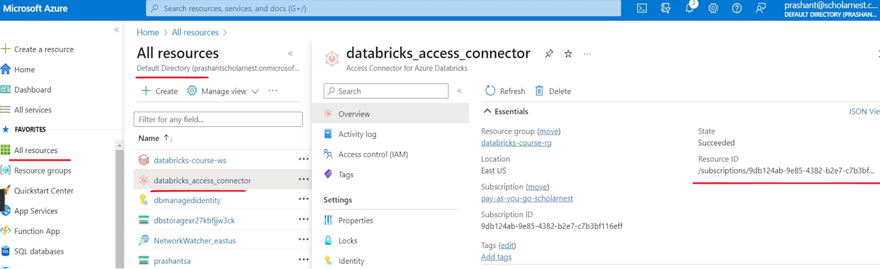

So it's done.

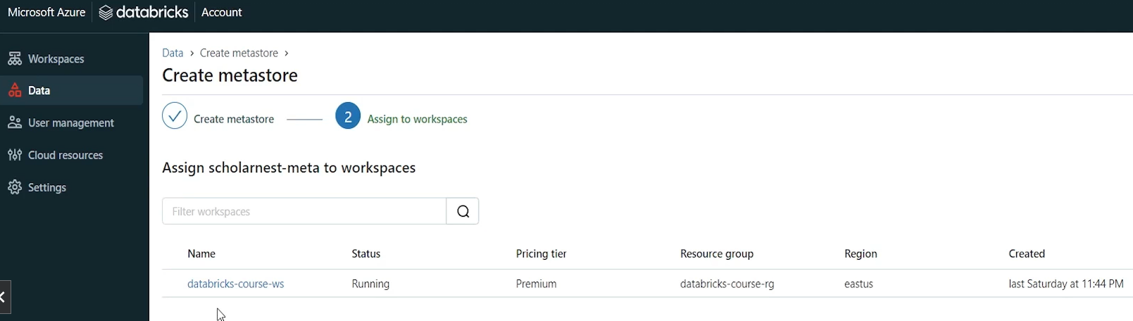

Now, what is this? This is my workspace name, right? I created a workspace here, this is databricks-course-ws. So I have only one workspace.

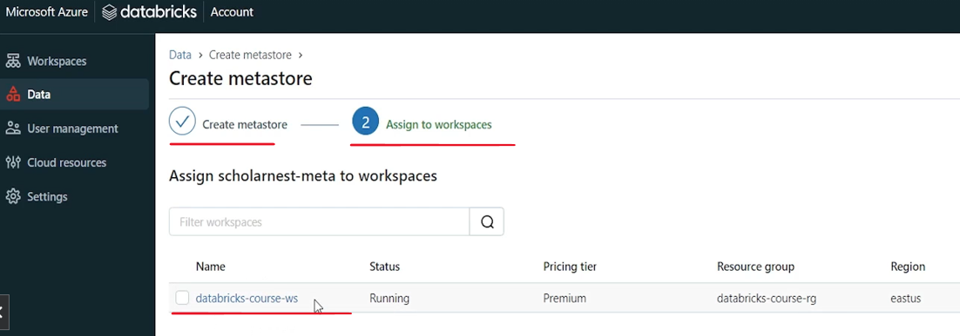

So now in this step Unity catalog is asking me that which workspace you want to connect with this metastore. So I'll choose my workspace. usually you may have two, three workspaces like one dev workspace, one QA workspace, one UAT workspace, one prod workspace. You can select all because the idea is to have a centralized unity catalog for the entire project, so you can connect all your workspaces, from here, with the single metastore, with the single unity catalog, and then manage permissions for all environments from a central place.

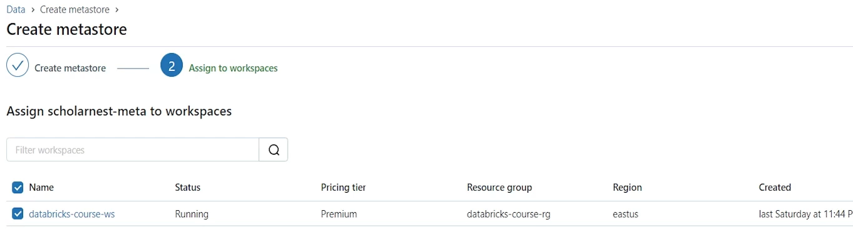

So let's assign it, just call it enable. And that's all within maybe few seconds it should be done.

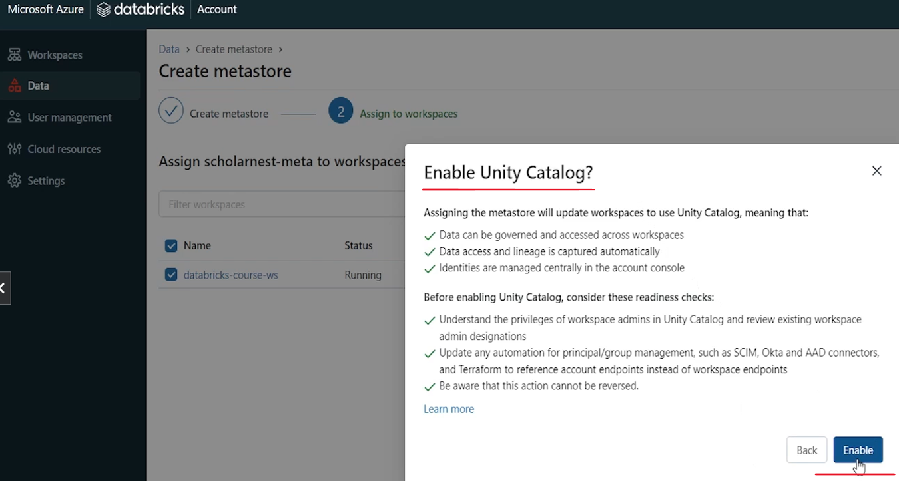

Congratulations. Let's close it. And we are done. So we are done setting up a meta store for unity catalog.

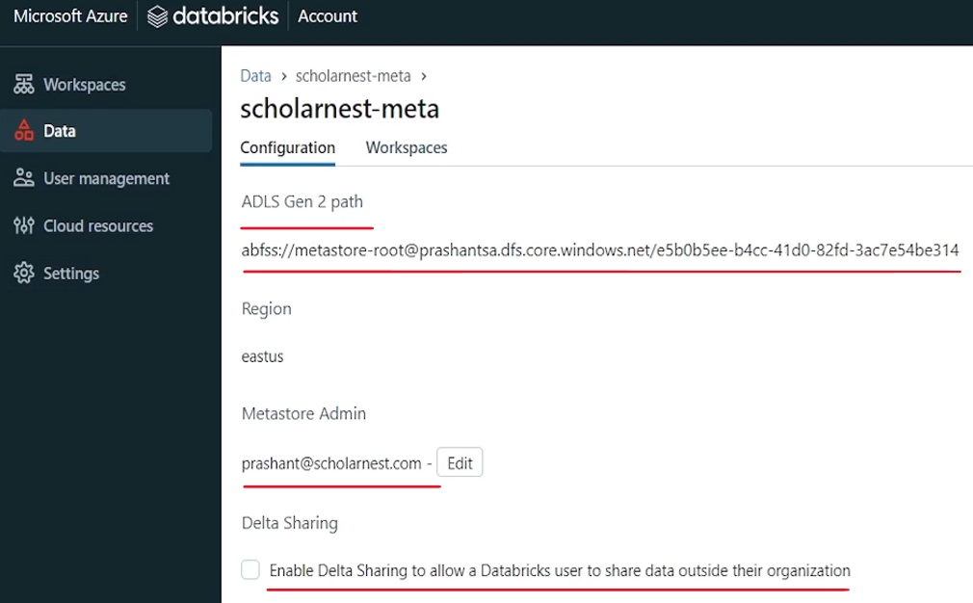

And this is the location where Unity Catalog will keep all the metadata. We know that this is the container name and this is the, um, storage account name, and rest is, Azure URL to access the storage account, and this is a directory which is automatically created by Databricks Unity catalog. inside the container region is east us. And this guy who created this meta store is the meta store admin. I can change the admin also so you can enable data delta sharing. But we are not going to enable it for now. So and if you come to workspaces so these are the workspaces that are connected with this meta store. You want to connect some more workspaces. You should create those workspaces. And you can come from here assigned to workspace. And you can connect those workspaces also with this meta store.

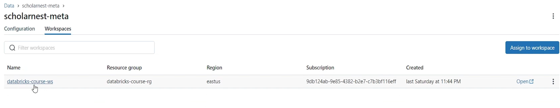

But we will go with one workspace. That's enough for our learning. So that's all we are done with. Step three. creating Unity catalog Metastore. Now next step is to provision your company users to unity catalog A. For granting privileges. For creating user groups, you need users. So we'll have to bring our enterprise users into unity catalog.

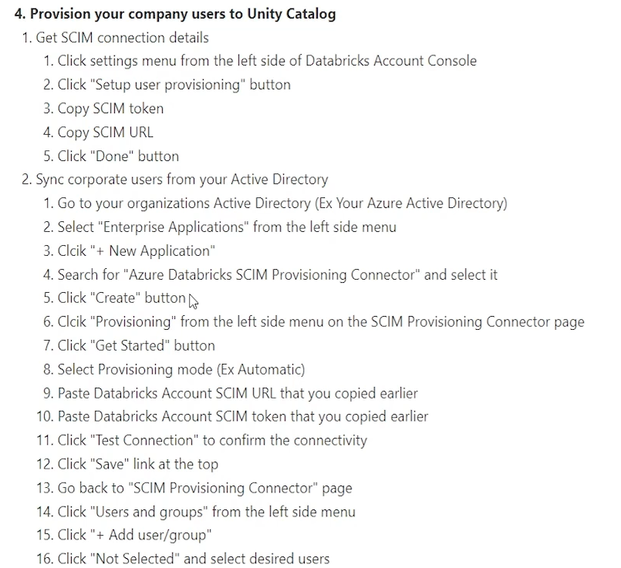

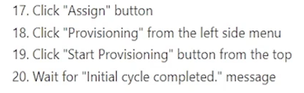

But we are done with the setting up Unity catalog. Unity catalog Metastore is setup. Workspace is connected. We are done. Next step is to bring users. And then we can start working on creating user groups and giving them different privileges. And then creating meta store objects like databases, tables and volumes and all that.